Northrop Grumman Arm Drill

Conceptual Design Report

Isaiah Padilla – Project Manager
Brandon Knutson – Manufacturing Engineer
Daniel Cooke – Financial Manager
Mason Goodman – Test Engineer
Mica Nellis – Logistics Manager
Russel Stringham – CAD Engineer

Fall 2023-Spring 2024


Project Sponsor: Northrop Grumman Space Systems
Sponsor Mentor: Andrew Acosta and Arjun Banerji
Instructor: David Willy

DISCLAIMER
This report was prepared by students as part of a university course requirement. While considerable effort has been put into the project, it is not the work of licensed engineers and has not undergone the extensive verification that is common in the profession. The information, data, conclusions, and content of this report should not be relied on or utilized without thorough, independent testing and verification. University faculty members may have been associated with this project as advisors, sponsors, or course instructors, but as such they are not responsible for the accuracy of results or conclusions.

EXECUTIVE SUMMARY
Northrop Grumman Space Systems initiated a project aimed at developing a robotic drilling arm capable of precisely locating drilling positions on any cylinder, crucial for assembling their launch vehicles. These vehicles utilize cylindrical composite materials to bolt secondary structures, serving as the backbone for connecting the entire launch structure. The drilling arm must account for varying cylinder sizes and materials while ensuring it can generate enough force to penetrate the targeted composite material, specifically aluminum in this instance. Initial financial provisions for this endeavor stand at $5,000, with the possibility of an additional $5,000 depending on design progression. To ensure adequate funding, the team has initiated fundraising efforts, targeting a sum of $1,000, which equates to 10% of the potential total budget.

The significance of this project lies in Northrop Grumman's quest for efficiency in design and production. The robotic arm is anticipated to streamline their design cycle, enabling the company to handle more processes in-house. Presently, Northrop Grumman often outsources specific tasks or tests to out-of-state entities. The robotic drilling arm's introduction is expected to curtail such dependencies, reducing the time lag between design and production. Throughout the project's conceptualization, the design underwent several revisions, with the team oscillating between multiple robotic arm models, ultimately settling on a four-degree freedom robotic drilling arm with spherical coordinates. This design was chosen for its adaptability and accuracy, even if it presents complexities in its realization.
Currently, the project is progressing as planned, with the team continuously adapting to new insights and challenges. Although certain design choices may appear redundant or challenging, the team remains committed to realizing a versatile and effective robotic arm that not only meets the client's specifications but also stands out during the Northrop Grumman Design Day. The collective objective is to provide a solution that can be feasibly integrated into Northrop Grumman's in-house operations.

TABLE OF CONTENTS
Contents
DISCLAIMER 2
EXECUTIVE SUMMARY 3
TABLE OF CONTENTS 4
1 BACKGROUND 6
1.1 Project Description 6
1.2 Deliverables 7
1.3 Success Metrics 7
2 REQUIREMENTS 7
2.1 Customer Requirements (CRs) 8
2.2 Engineering Requirements (ERs) 9
House of Quality (HoQ) 9
2.3 House of Quality (HoQ) 10
3 Research Within Your Design Space 10
3.1 Benchmarking 10
3.1.1 System-level Benchmarking – Russel Stringham 10
3.1.2 End Effector Benchmarking – Isaiah Padilla 11
3.1.4 Robotic Arm Wiring / Cables - Mason Goodman 13
3.1.5 Bearings and Slewing Drives – Mica Nellis 13
3.2 Literature Review 14
3.2.1 Isaiah Padilla 14
3.2.2 Brandon Knutson 17
3.2.3 Daniel Cooke 18
3.2.4 Mason Goodman 19
3.2.5 Mica Nellis 21
3.2.6 Russel Stringham 24
3.3 Mathematical Modeling 26
3.3.1 Required Force & Torque for Drilling Through Aluminum – Isaiah Padilla 26
3.3.2 Use of Engineering Tools in Robot Drilling Arm Development – Brandon Knutson 26
3.3.2.1 Potential Use of RoboDK for Simulation and Control – Brandon Knutson 26
3.3.2.2 University of Wollongong Paper on Servo Motor Control - Brandon Knutson 27
3.3.2.3 Reverse Kinematic Equations for Robot Arm Control - Brandon Knutson 27
3.3.2.4 Motor Control for Cylindrical Linear Motion – Brandon Knutson 27
Input Data and Processing 27
Path Optimization 28
Command Generation for Smooth and Linear Motion 28
Improved Drilling Efficiency 28
3.3.3 Cable / Wire Size to Power End-Effector – Mason Goodman 28
3.3.4 Reliability of Bearings – Mica Nellis 29
3.3.5 Linear Actuator – Russel Stringham 30
3.3.6 Deformation – Daniel Cooke 30
4 Design Concepts 32
4.1 Functional Decomposition 32
4.2 Concept Generation 33
4.2.1 Initial Process of Overall Drill Arm Concept Generation 33
Initial Concept: Six Degrees of Freedom 33
Transition to Scara Robot 33
Experimentation with Three Degrees of Freedom 33
Four Degrees of Freedom with Spherical Coordinates 33
4.2.2 End Effector Material Composition – Isaiah Padilla 34
4.2.3 Power Transmission Concept Generation – Brandon Knutson 34
4.2.4 Arm Concepts – Daniel Cooke 35
4.2.5 Electrical Component Wiring – Mason Goodman 35
4.2.6 Bearing Concepts – Mica Nellis 35
4.2.7 Linear Actuator – Russel Stringham 35
4.3 Selection Criteria 35
4.3.1 Selection Criteria for End Effector Materials – Isaiah Padilla 35
4.3.3 Arm Selection Criteria – Daniel Cooke 37
4.3.4 Wiring Selection Criteria – Mason Goodman 37
9.2.2 Bearing Selection Criteria – Mica Nellis 38
4.4 Concept Selection 38
4.4.1 Top-level Concept Selection – Brandon Knutson 38
4.4.2 End Effector Selection – Isaiah Padilla 39
4.4.3 Power Transmission for Power Transfer – Brandon Knutson 40
4.4.4 Arm Concept Selection – Daniel Cooke 40
4.4.5 Wiring Selection – Mason Goodman 41
4.4.6 Bearing Selection – Mica Nellis 42
4.4.7 Linear Actuator – Russel Stringham 43
5 Schedule and Budget 43
5.1 Schedule 43
5.2 Budget 46
5.3 Bill of Materials (BoM) 47
6 Design Validation and Initial Prototyping 47
6.1 Failure Modes and Effects Analysis (FMEA) 47
6.2 Initial Prototyping 48
6.2.1 Physical Prototype 1 48
6.2.2 Virtual Prototype 1 48
6.3 Other Engineering Calculations 48
6.3.2 Power Supply Needed for Prototyping 49
6.4 Future Testing Potential 50
7 CONCLUSIONS 51
8 REFERENCES 53
9 APPENDICES 57
9.1 Appendix A: Pillow Bearings Chosen from GlobalSpec 57
9.2 Appendix B: FMEA Table 58
9.3 Appendix C: Final Product Bill of Materials 59

1 BACKGROUND
This chapter is dedicated to providing readers with the necessary information needed to understand what this project is about, why it exists, and the importance it carries for the client. Other necessary information covered includes the deliverables which will be presented throughout the duration period of this project and most important of all, what success means for the project by the team and client’s standards.

1.1 Project Description
Northrop Grumman Space Systems proposed the creation of a robotic drilling arm, with the primary objective of this project being to design an arm with a drill tool capable of locating positions on any cylinder to aid in drilling. Given that Northrop Grumman has launch vehicles that are used within a variety of different areas, including designing launch vehicles, and these cylinders that we will drill into to connect the entire vehicles together. These launch vehicles include cylindrical composite materials to bolt secondary structures which is what is used to connect entire launch vehicles together. The team’s drill, as stated previously, will need to locate positions on any cylinder to assist with drilling and apply enough force to drill through a composite material. Given that not every cylinder is the same diameter and material, it is expected that we accommodate for different bolt clearances and the force that is applied to drill through the material is enough for at least what is expected to be used within the competition. The team only knows small yet extremely important details regarding size constraints, money constraints, and what the arm drill expected to complete during Northrop Grumman Design Day.
Through meeting with assigned clients, we discovered information that will greatly impact the success of this project including customer requirements and constraints, along with that the team dove into various concepts that were slightly vague within the proposal given. Items such as what material is expected to be drilled through, size expectation of the design, whether it needed to be autonomous; the answers received, respectively are aluminum, four feet tall and 50-inch diameter, and that being autonomous was a requirement.
The budget for this project has a small amount of room for change as the design progresses, allotted a first amount of $5,000.00 pending upcoming design decisions potentially having an additional $5,000.00 if the design requires more than the initial amount. Given what is being asked of the team it is anticipated that more than the initial five thousand dollars will be used, so the team has planned on a fundraising target of $1,000.00 which is ten percent of the total $10,000.00 as required by David Willy. As of now the team’s budget manager is reaching out to various companies in hopes of getting donated materials and/or money donations. Along with those details as a team we decided to do a small self-donation leading up to the first prototype of $50.00 each totaling $300.00 as a first step toward the requirements of ten percent team-fundraising.
This project is important because Northrop Grumman Space Systems is always looking for what is more efficient in regard to speed and efficiency in designing. By creating this robotic arm, the overall design cycle will improve and add adds to the internal availability within their company which in turn drives their designs. Northrop Grumman was in search of finding a design that allowed for easier manufacturability as well as “wanting to do things in house”, as stated by the team’ clients, and the team creating a robotic drilling arm for these launch vehicles allows for a major step in that direction. By having a design such as what is proposed for this capstone allows for Northrop Grumman to avoid the time factor, meaning that they often have to go out of state to get certain things made or tested, and having such an impactful device the time to accomplish certain deliverables will be shortened immensely.

1.2 Deliverables
The team is tasked with several deliverables throughout this course, some of which are more important than others. Although each deliverable is imperative to the success of the team as well as this project, there are a select few that will directly impact what is designed, how the drilling arm is designed, and why specific design choices are made. The most impactful deliverable throughout this course are the first and second prototypes as completing these prototypes will show what the team has planned to implement different requirements set by the clients into the design that we were tasked with. Along with that each prototype is a milestone that is completed to show the overall progress of the design, meaning that within the first prototyping process the team knows the standings for completing this project as well as what is to come leading to prototype two. Following this the website being created will also heavily aid in the success of this project, it will allow for various important members of the completion and success of this project to see the progress being made. Websites can also allow for different networking opportunities for the team, it can be extremely helpful when considering the 10% fundraising amount that is included within the total budget. The reason for this is because when asking a business/person to donate money, materials, or discounts whomever they are will likely want more information in regard to who they are giving this to, a website can allow for any person interested in this project to have easy access to what is being done and why it is important.
Northrop Grumman Space Systems is also asking the team to complete different deliverables by certain deadlines. There is no deliverable within what is being asked that is more important than the other regarding the clients, they each hold extreme value and importance. The team is tasked with completing Preliminary Design Review (PDR) and Critical Design Review (CDR) presentations that may be virtual or in person. The PDR presentation is necessary in showing the groundwork for what the design will likely be, like prototype one within this course it will be a deliverable that shows overall progress and intentions for the design. On the contrary, the CDR presentation will only happen once the team has a completed prototype allowing for a much more refined and rounded idea of the overall design.
Following all deliverables throughout the course as well as with the clients the team will participate in Northrop Grumman Design Day. This is a competition that includes, NAU, ASU, U of A, and ASU Polytechnic, all teams will bring their final design and perform what is being asked for by the clients, this can be seen in section 1.1, and what the team has been designing towards throughout the duration of the course. Thus, having a design that fits a certain size constraint as well as fully function within all aspects that the team was tasked with.

1.3 Success Metrics
For this team, success will be directly impacted by the robotic actually functioning, the idea of making this robotic arm move to exact points on a cylinder and be able to drill through them with almost perfect accuracy will prove success. Along with that, the team needs to have drilling operations that can withstand certain amounts of force and torque to be successful during competition. Using a coding program that one of the team members has created during prototyping to make sure that there is accuracy in picking different points within a cylinder as well as potentially having the shortest distance to those points. Using different programs like Simulink, and MotionGen to see just how this robotic arm will move and function during the completion of different operations it is programmed with will give the team a strong understanding of how successful the robotic drilling arm will be.

2 REQUIREMENTS
The purpose of this chapter is to discuss and quantify the requirements and procedures that the final product must be able to perform as gathered from meetings with the client. The first section of the chapter details the customer requirements as gathered from client meetings as well as the initial project proposal. The second section takes the customer requirements and turns them into quantifiable engineering requirements. These engineering requirements are necessary to define prior to the design phase, as all design aspects revolve around the final product meeting or exceeding these engineering requirements. The engineering requirements are the fundamental basis of all future engineering calculations. The final section of this chapter
The project proposal defines the objective of the final product as an articulating arm drill tool that self-locates and is capable of applying enough force to drill holes through the inside of a composite cylinder. The project is divided into two parts. Project A, the higher priority project, requires the team to focus on the self-locating aspect of the drilling arm, which would allow in-house technicians to mark the exact location of a desired hole. Project B emphasizes the entire articulating arm, which should be able to drill horizontally at any location within the cylinder.

2.1 Customer Requirements (CRs)
Essential Customer Requirements
- Drilling end effector must reach a maximum diameter of 50 inches and a maximum height of four feet.
This is the maximum size cylinder that the drill will be used for. It was discussed during a client meeting that the minimum diameter may be 40 inches, with a minimum height of two feet. However, the main goal is to reach the original work volume as explicitly stated in the client meeting.
- Drill must be able to drill through a composite material equivalent to ¼ ‘’ aluminum at an angle perpendicular to the surface.
The real product will be drilling through a carbon-fiber composite material, however for the purposes of this project, the clients stated that the team could use ¼’’ aluminum for design tests.
- Drill must be self-locating.
It is expected that a technician will be able to send the hole locations to the drilling hardware. The drill will then be able to drill the exact number of holes at an exact location without any further intervention from the technician.
- Entire drilling apparatus must be portable.
A two-man team of technicians must be able to roll the drill to a desired manufacturing location where the cylinder will be dropped in around it before the drilling operation.
- Drill must have an emergency stop override function (e-stop).
In an event where the machine overheats or experiences any other catastrophic failure, it must be capable of shutting down without the need for human intervention.
- Drill must run strictly on electric power.
The drill will not have access to hydraulic lines; therefore, it should only run on a standard household appliance power supply.
- Drill must be able to work continuously throughout a 10-hour day without maintenance.
- Entire project cost must fall within the $5,000 budget, with the opportunity to increase to $10,000.
The stated budget for the project is $5,000, however if the client considers it to be beneficial to the team, the budget will increase to as much as $10,000.
Non-essential Customer Requirements
- End effector should have multiple drill bits for different job types.
Various jobs will require different sized holes, therefore requiring different drill bits.
- Drill should be capable of drilling in various directions, on varying surfaces, including flat plates or on the interior of a cone.
It is the goal of the clients to implement the technology developed within this project for more extensive jobs, like flat plates and conical surfaces.
- User interface with preprogrammed settings for known jobs.
Ideally, a technician would be able to use a digital interface that would allow for a preprogrammed setting to be selected. However, it is likely that the G-code would be sent from a laptop to the robot prior to job execution.

2.2 Engineering Requirements (ERs)
- Drilling must meet a minimum tolerance of .003 inches.
- The drill must not exceed a maximum deflection of more than .001 inches at the tip of the end effector.
- The drill or spindle must spin at a minimum of 3000 rotations per minute.
- The drill must apply 153 N-m of torque.
- The end effector must push the drill bit against the drilling surface with a minimum force of x lbs.
- The joint motors must be able to supply 180 N-m of torque.
- The motor holding torque must be 150 N-m with the gearbox included.
- The slewing drive must have a range of motion of 360 degrees.
- The joint motors must have a range of motion of 180 degrees.
- Entire portable assembly must weigh no more than 250 pounds.
- Entire assembly must cost less than $5,000 (possibly $10,000)
- Drill bits must be able to withstand 10 jobs per day before replacement.
- All other robot arm elements and hardware must be able to withstand 100 total jobs before replacement or routine maintenance.

House of Quality (HoQ)
The House of Quality (HoQ) is displayed below in Figure 2.1 as a foundational concept in the Quality Function Deployment (QFD) methodology, a structured approach to product design and development. The House of Quality visually represents how customer requirements relate to specific design attributes or features of a product. Its structure, resembling a house, consists of several components: the customer's needs or "whats" on the vertical side, the product's technical requirements or "hows" on the horizontal side, and a matrix in the middle showing the relationship between the two. The "roof" of the house represents the interactions between technical requirements, and the "foundation" or the bottom part often includes benchmarking against competitors. The objective of the House of Quality is to ensure that the voice of the customer is systematically and comprehensively translated into the design of a product or service, thereby enhancing customer satisfaction and minimizing design iterations.

2.3 House of Quality (HoQ)
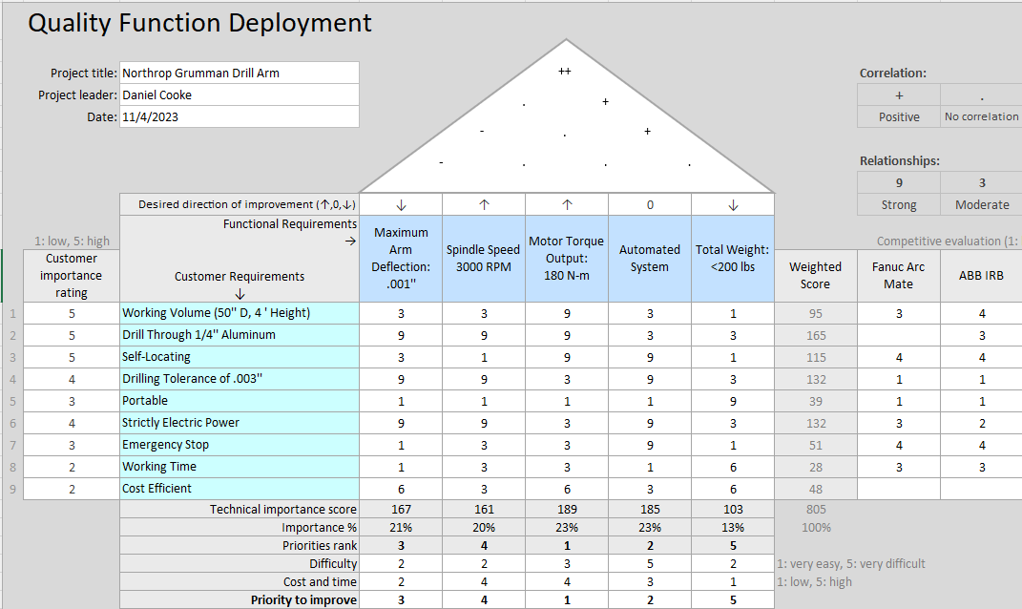
Figure 2.1: House of Quality
The updated house of quality depicts changes in the functional requirements associated with the project. From the engineering calculations, the team was able to compute the necessary minimum functional outputs for the minimum viable product. Given the drilling tolerance of .003’’, it was determined that the maximum allowed deflection during the drilling operation should be .001’’ to allow for more error with the spindle. From research it was determined that the optimal drilling speed through quarter inch thick aluminum is 3000 rotations per minute. Given the predicted weight of the arm along with a maximum spindle weight of 22 pounds, the required torque output from the stepper motors is 180 N-m. This will only be achievable with a gear box of 9:1 gear reduction. The entire system will need to be portable and capable of being locked into placed prior to the drilling operation. It is assumed that it will be able to be rolled into the desired location by no more than two people, and therefore it should weigh no more than 200 pounds total. At the bottom of the QFD it can be seen that the largest priority of improvement is the motor torque output. If the motors are unable to hold the robot arm, let alone move it vertically in its most extended state, no other function is achievable. The second most important function is the automated system. The main idea of the project is to develop a self-locating robotic arm, prior to making it capable of drilling, so this is an essential function. Outside of the slewing drive, the costliest components of this project will be the motors and the spindle to achieve these desired functional requirements.

3 Research Within Your Design Space

3.1 Benchmarking

3.1.1 System-level Benchmarking – Russel Stringham
In benchmarking the whole system, the team researched two robotic arms and a drill. The first drill was a Fanuc welding robot that was light weight and compact. It had high speed and accuracy because of new servo motor technology. For the specifications it has a payload of 3 kg, moves on six axes, and has a reach of 1437 mm. The next robot was an ABB IRB 1600ID which is also a welding robot. This robot is like the Fanuc for its light weight and 6-axis. This one, however, has internal wiring the creates a flexible and compact design. For its specification it has a payload size of 4 kg and a reach of 1500 mm. Both robot arms will be useful for the team's design because the arm layout and pinpointing locations are designs that our arm could use. In addition, their ability to install on the floor, ceiling, and at an angle is something our team will need to incorporate. The last system-level benchmarking was for the drill in which the team found the VEVOR Magnetic Drill. It is portable and compact that has quick changing bits which is needed for our design. The drill is a twist and hole drill that has adjustable speed gears.

3.1.2 End Effector Benchmarking – Isaiah Padilla
To discern what material would be best for the drill bits when it came to drilling through aluminum, three initial materials were selected for comparison based on selected resources [48]. These are cobalt, high-speed steel (HSS), and titanium aluminum nitride (TiAlN), the last of these being a coating for what is typically an HSS drill bit. Each material offers distinct advantages based on their material properties, particularly when considering yield strength, modulus of elasticity, and thermal conductivity.
TiAlN drill bits are coated with a layer of Titanium Aluminum Nitride. These bits don't necessarily rely on the yield strength of TiAlN itself but rather on the substrate material, usually tungsten carbide or HSS. The TiAlN coating enhances the tool's life by offering high heat resistance and reduced friction. Its modulus of elasticity, though specific values might vary, tends to be high, which indicates stiffness and resistance to deformation. Its primary advantage lies in its impressive thermal conductivity properties. TiAlN can withstand higher temperatures compared to HSS or pure cobalt drill bits, which means that when drilling at high speeds, the heat buildup doesn't degrade the tool as quickly. This leads to longer tool life and the ability to maintain sharpness over extended periods.
High-Speed Steel (HSS) drill bits are among the most common drill bits in the market. HSS exhibits a good balance between hardness and toughness. Its yield strength is decent, making it sufficiently robust for many standard drilling applications. The modulus of elasticity for HSS is typically around 200-210 GPa, reflecting its relative stiffness. HSS bits have moderate thermal conductivity, which is lower than that of TiAlN. While they can withstand relatively high drilling speeds, they are not as heat-resistant as TiAlN-coated bits. Their main advantages are their versatility and affordability, making them suitable for general-purpose drilling. However, they might not last as long as cobalt or TiAlN bits when used intensively.

Cobalt drill bits, typically made from solid cobalt alloys or HSS with a certain percentage of cobalt, are known for their durability and resistance to heat. The addition of cobalt increases the yield strength of the bit, allowing it to drill through harder materials like stainless steel without dulling quickly. The modulus of elasticity of cobalt alloys is quite similar to HSS, granting them stiffness. In terms of thermal conductivity, cobalt drill bits tend to fall between HSS and TiAlN, giving them a balance of heat dissipation and hardness. The primary advantage of cobalt bits is their ability to maintain sharpness and resist heat when drilling through hard materials. They tend to be more expensive than standard HSS bits but are often more cost-effective for heavy-duty applications due to their extended lifespan.

In conclusion, the choice between TiAlN, HSS, and cobalt drill bits largely depends on the specific drilling requirements. TiAlN offers excellent heat resistance, HSS is versatile and cost-effective, while cobalt provides longevity when drilling through tough materials. Each material's yield strength, modulus of elasticity, and thermal conductivity play crucial roles in determining its suitability for various applications. Table 3.1 below represents the specific values for each of the specified properties of each material.

Table 3.1: End Effector Drill Bit Material Properties
Material [9] | Cobalt | High Speed Steel | Titanium Aluminum Nitride (TiAlN) Coating
Properties | S(y) = 225 MPa[10]  E = 211 GPa  K (thermal conductivity) = 69.21 W/m-K | S(y) = 180 – 500 MPa [11]  E = 200 GPa [12]  K = 41 W/m-K [13] | E = 600 GPa [14]  G (shear) = 240 GPa  K = 19.0 W/m-K
Advantages | Preferred material for drilling aluminum, best thermal conductivity, mid yield strength and acceptable E-value | Can have higher yield strength than cobalt but comes at the cost of a worse thermal conductivity value | Coating for drill bits, not a full material, have a long lifespan, and are good for drilling both hard and soft metal
Disadvantages | Costly and can be brittle if not cared for properly | Not suitable for drilling through tougher materials | Once coating wears out, the bit cannot be used until the coating is reapplied

3.1.3 Benchmarking in the Design of the Robot Drill Arm - Brandon Knutson
In the process of designing the robot drill arm, an essential phase involved benchmarking key components and technologies that would play a critical role in the arm's performance and functionality. This section discusses the key aspects of benchmarking that were undertaken during the design phase.
Servo Motor Selection:
One of the fundamental aspects of our design was the selection of appropriate servo motors to power and control the robot arm's movements. To ensure the arm's swift and precise operation, a comprehensive investigation into various servo motor specifications and manufacturers was conducted. This involved scrutinizing factors such as torque, speed, precision, and compatibility with our control systems. The aim was to identify servo motors that would meet the specific demands of our robot drill arm's design.
Control Methods and G-Code:
Efficient control methods were another critical element of our benchmarking process. We explored different methods of controlling the robot arm, including programming it with G-code instructions. This phase involved assessing the feasibility of using industry-standard G-code and exploring alternative control techniques that would enhance the arm's versatility and adaptability in different applications.
Power Transmission Mechanisms:
Benchmarking extended to the evaluation of power transmission mechanisms. We briefly investigated the use of slewing drives and cycloidal drives to transfer power from the servo motors to the arm's components. These mechanisms were assessed in terms of their efficiency, reliability, and suitability for the robot drill arm's intended tasks. Further discussion will be found in section 5.3.6
System Dynamics and Nonlinear Control:
Incorporating knowledge gained from my coursework in nonlinear and system dynamics classes, we have focused on designing the robot control system. Lessons from these classes have provided valuable insights into how to model and control complex mechanical systems, including the robot drill arm. These principles have been instrumental in shaping the control algorithms and strategies we are developing to ensure the arm's stability and performance during operation.
In conclusion, benchmarking played a pivotal role in guiding the design of the robot drill arm. We carefully assessed the selection of servo motors, control methods, power transmission mechanisms, and leveraged insights from our coursework to create a robust and efficient system. These benchmarking efforts are crucial in ensuring that the robot drill arm will meet its intended objectives while maintaining a high level of performance and precision.

3.1.4 Robotic Arm Wiring / Cables - Mason Goodman
The electrical components of industrial robotic arm devices regularly contribute to overall failure and down-time. Wiring and cables within robotic arm applications undergo extensive bending and torsion due to the constant movement of the arm components themselves. Through benchmarking of “state-of-the-art” robotic arms, it was determined that industrial robotics utilize “continuous” and “torsional” flex cable that resist abrasion due to repeated stresses. In an industry that requires robotic mechanisms to endure repeated jobs before scheduled maintenance, it is important team design implements electronic components that can withstand stresses beyond that of an individual use. Through further research, it was determined cable/wire manufactures include a “flex-life” for respective cables that rates the longevity of cables for a specified number of “cycles”. Wiring “cycles” are often considered a 90° bend or twist in any direction. Currently, there is not a standard test for wiring “flex-life”, and most manufactures have various differing tests that are given to determine the “flex-life” of a cable. However, through research of multiple electrical manufactures it was determined the average range of a “continuous flex” cable/wire is approximately 1 to 5 million “flex cycles”.

3.1.5 Bearings and Slewing Drives – Mica Nellis
Benchmarking bearings will prove to be important in the design's overall function. The clients are expecting the team to create a robotic drilling arm that has an extremely high run time, an entire workday. This constraint will weigh heavily on the bearings chosen, with there are three diverse types of bearings that need to be considered within the overall design. The first one being a turntable bearing, this selection of bearing will be almost absolute because it is one of the only bearings that is big enough for the base of the robotic drilling arm, they come in varying sizes although we will use the biggest one available, which is 12 inches in diameter. The turntable bearing that was found is on a website called Bear Woods, this website was the only one that was found that can meet the size requirements we need for the turntable bearing, all others were slightly too small for what the team was trying to accomplish. The second bearing that was benchmarked was a pillow block bearing using a website called GlobalSpec, this website allows for different constraints to be inputted into a filter and outputs bearings that meet those constraints.[37] This will be discussed further within section 3.2.5, using these pillow block bearings will help the team meet the requirement of this design running for a full workday as well as being very durable. Along with the pillow block bearing a flange bearing will be considered because it is remarkably similar to a pillow block bearing other than its mounting style, the pillow block bearing shaft mounts parallel to the surface whereas a flange bearing shaft mounts perpendicular to the the surface. The last bearing that was benchmarked was the thin section bearing, this bearing is what is often used within robotic drilling arms because of is low key features taking up small amounts of space and its ability to take the place of two bearings depending on its application. Although this bearing is benchmarked it was not recommended by the clients because it is not as durable as the pillow block bearing. Even though this is true it is still important for the team to consider all options regarding bearing as progression is made within this project.
The slewing drive will be an extremely important benchmarking process because this will be the sole provider of rotation at the base of the final design. The team hopes to have the drive donated or discounted because of our overall budget as well as meeting the fundraising required throughout this design. Having a slewing drive will be extremely imperative to how the overall performance of the design will go during design day. There has to be enough torque output for the design to rotate for various amounts of time, potentially an entire workday. There are various size constraints and power constraints when picking the best slewing drive for the team's robotic drilling arm.

3.2 Literature Review

3.2.1 Isaiah Padilla
[1] R. G. Budynas and J. K. Nisbett, “Chapter 9 - Welding, Bonding, and the Design of Permanent Joints,” in Shigley’s Mechanical Engineering Design, 11th edition, SI units, 11th ed, S.l., NY: MCGRAW-HILL EDUCATION (AS, 2020, pp. 485–612
This chapter discusses joining processes like welding, brazing, soldering, cementing, and gluing are vital in modern manufacturing, especially when assembling or fabricating parts. These methods are especially cost-effective for thin sections, as they eliminate the need for individual fasteners and associated assembly costs. Some of these processes even allow for speedy machine assembly. In the past, riveted permanent joints were commonly used for fastening steel shapes, with the captivating process of hot rivets being thrown and pneumatically hammered. This chapter was useful for guiding the team on how best the robotic drilling arm can be assembled and held together.

[2] R. G. Budynas and J. K. Nisbett, “Chapter 4 - Deflection and Stiffness,” in Shigley’s Mechanical Engineering Design, 11th edition, SI units, 11th ed, S.l., NY: MCGRAW-HILL EDUCATION (AS, 2020, pp. 173–219
All materials deform under stress, either elastically or plastically. The rigidity of a body depends on the context; for instance, a wire rope can be both flexible and rigid depending on the type of load applied. The importance of understanding deformation becomes clear in design scenarios. For example, snap rings must be both flexible for assembly and rigid for holding parts. In transmissions, excessive flexibility in shafts can lead to malfunction and premature wear. Similarly, in the steel industry, rolls need precise curvature to produce uniform sheet thickness, requiring knowledge of how much they'll bend during the process. Many times, the design of load-bearing components is based on deflection rather than stress limits. This chapter delves into the distortion of individual bodies due to their shape and load and touches upon the behavior of body groups. The chapter covers spring rates, tension, compression, torsion, deflection due to bending, elastic stability, shock, and impact. This has been helpful for guiding the team on how to calculate the deflections of the robotic drilling arm components, as well as to calculate how the robotic arm will react when experiencing high amounts of torque during drilling.

[3] G. R. Reddy and V. K. Eranki, “Design and Structural Analysis of a Robotic Arm,” thesis, Karlskrona, 2016
This thesis paper discusses traditional metalworking processes, specifically shearing, and its associated risks when conducted manually. Shearing, a mechanical operation, involves cutting large metal sheets into smaller, predetermined pieces. Given the inherent dangers of manual shearing, the article introduces a project to automate this process. The proposed system employs a pick-and-place robotic arm, designed to lift and transport metal sheets from their stacks to the shearing machine. The arm's movement is facilitated by RCC control, enhancing its efficiency and safety. A significant challenge was designing the robotic arm to fit within the confined spaces of the industry environment. Stress and movement tests on the arm revealed it could transport sheets in just 7.5 seconds, a reduction from an initial 18 seconds. Though this speed may require adjustments in real-world applications, the simulation suggests that the machine can efficiently operate at both high and reduced speeds. The aim is to enhance workplace safety and productivity through automation. This thesis has helped give the team some guidance in creating "joints that move in vertical and horizontal directions”.

[4] R. Gautam, A. Gedam, A. Zade, and A. Mahawadiwar, Review on Development of Industrial Robotic Arm. International Research Journal of Engineering and Technology, 2017
This paper focuses on a robotic arm designed to mimic human arm movements using accelerometers as sensors. This control method offers more flexibility than controlling each actuator individually. The system processes input from the accelerometer to replicate human arm movements. The project's objectives, developing both the hardware and software for this accelerometer-controlled robotic arm, have been met successfully. Observations confirm the arm's precision, accuracy, and user-friendliness. The innovation is expected to enhance the efficiency and safety of tasks such as handling hazardous materials. This paper has shown the team how a robotic arm can be created as "lightweight and [using] lightweight materials".

[5] X. Zhang, M. Huang, M. Lei, H. Tian, X. Chen, and C. Tian, “Improved Rapid-Expanding-Random-Tree-Based Trajectory Planning on Drill ARM of Anchor Drilling Robots,” Machines, vol. 11, no. 9, p. 858, Aug. 2023, doi: 10.3390/machines11090858.
The paper focuses on the trajectory planning of robotic arms used in coal mines, specifically the drilling arm of an anchor drilling robot. The current manual methods for coal mine excavation in China are inefficient and pose high safety risks. There is a push towards automating these processes to improve safety and efficiency. The paper discusses the challenges of designing robotic arms for such environments, emphasizing the importance of effective trajectory planning to optimize the robot's movement. Various existing trajectory planning methods, including the basic RRT algorithm, are examined. The paper proposes an improved RRT algorithm that offers a more efficient and smoother trajectory, showing a 22% increase in sampling and path generation speed and a 14% reduction in path length. The findings suggest that the enhanced algorithm offers robust and real-time solutions, making it a valuable tool for optimizing the movements of anchor drilling robots in coal mines. This paper has proved particularly useful when it comes to making sure the team’s design will be able to move precisely and accurately using an algorithm.

[6] M. Fairchild, “Drilling robots: Automate for fast and precise results,” #HowToRobot, https://howtorobot.com/expert-insight/drilling-robots (accessed Sep. 15, 2023).
Drilling robots, used in industries such as automotive, aerospace, electronics, and medical equipment, are enhancing productivity and efficiency in various sectors. These robots can automate processes that have traditionally been done manually, resulting in improved accuracy, repeatability, speed, and reduced labor costs. The primary advantage of these robots is their reliability, as they can operate non-stop without fatigue. When considering the integration of a drilling robot, factors such as the material being drilled, the type of hole, the required force, and the rotational speed play a significant role in the choice of robot. The End-of-Arm-Tooling (EoAT) can be changed to perform various functions, such as tapping or deburring. Costs for these robots vary based on their specifications, with larger robots designed for drilling into harder materials like metals typically being more expensive. Maintenance, safety, and additional components like cooling systems or vision systems are other considerations. There's also a market for used and reconditioned robots, which offers a cost-effective solution for those looking to integrate these systems. This site helps the team understand which industries are already using drilling robots, the main uses for various robots in the industry, and provides potential outreach opportunities for not only more advice but as well as donated materials.

[7] T. Xometry, “Drilling machines - parts, types, and uses,” Xometrys RSS, https://www.xometry.com/resources/machining/drilling-machines/ (accessed Sep. 15, 2023).
Drilling machines are tools specifically designed to bore precise cylindrical holes into various materials. They come in various types, each with its specific advantages and applications. The main components of a drilling machine include the base, column, arm, drill head, worktable, feed mechanism, spindle, chuck, and electric motor. Common drilling machine types include CNC drilling machines, sensitive drilling machines, radial and upright drilling machines, gang drilling machines, deep-hole drilling machines, and portable drilling machines, among others. The appropriate type of drilling machine depends on the specific application and production requirements. For instance, CNC drilling machines offer high precision and are ideal for large-scale production, while portable drills are suitable for home use. Overall, drilling machines play a critical role in many industries and are essential tools for workshops. The website shows different "parts of a drilling machine, the different types of machines available, and the specific uses of these machines". This has been extremely handy for the team through this part breakdown.

[8] R. Cheaytani, “Choosing the right drill bit,” Buying Guides DirectIndustry, https://guide.directindustry.com/choosing-the-right-drill-bit/ (accessed Dec. 1, 2023).
The article provides guidance on choosing the right drill bit based on various factors. It emphasizes the importance of considering the material to be drilled, citing specific hardness and mechanical properties. The key criteria include drill bit material (such as HSS or tungsten carbide), fit for the machine used, diameter, type (twist, step, reamer, etc.), coating, bit angle, and length. The choice between solid drill bits and those with interchangeable inserts is discussed, highlighting that insert drill bits are suitable for large diameter holes, while solid bits offer more rigidity for smaller diameters. A very helpful table is included within the article, detailing and categorizing various drill bits into types, main fit, material used, quality, specific characteristics, and drilled materials. The article continues by investigating the materials used for drill bits and cutting inserts, as well as detailing the advantages and disadvantages of hard metal, HSS, carbide, and ceramic options. Various coatings such as diamond, CBN, and PCD are also covered. The piece concludes by outlining different drill geometries and shanks for machine tool drill bits, along with industry standards (DIN) for specific types of drill bits.

[9] A. Tyurnina, “Drill bit selection,” Inrock, https://www.inrock.com/drill-bit-selection/ (accessed Dec. 1, 2023).
This article addresses the complexity of choosing the right drill bit for drilling operations, particularly in the context of horizontal directional drilling (HDD). Several different types of bits, such as spade, drag and shear type bits, PDC bits, milled tooth, and TCI roller cone bits, are discussed, along with factors like IADC codes, bearing types, and bit categories. The article suggests a systematic method involving four steps: Identification of the soil/rock type, classification of the soil/rock category based on compressive strength, selection of a bit type within the category, and optimization and adjustment of operating parameters. The importance of obtaining geotechnical information through site surveys, contacting relevant authorities, and collaborating with tooling suppliers is emphasized. The classification of soil/rock categories based on compressive strength is provided, and bit selection recommendations are outlined, progressing from softer to harder formations. The article also highlights general considerations, such as rig operating limits, torque requirements, weight on bit, and the preferred use of sealed, friction-bearing, or roller cone bits for fluid applications. The importance of optimizing bit selection by consulting suppliers, identifying cuttings return characteristics, and considering rig operating costs is reiterated multiple times. It should be noted that though the article is meant for drilling through non-metal material outdoors, the same principles introduced and discussed still apply to the purposes of this project.

[10] M. Lynch, “5 tips for selecting the optimal Spindle Range,” Modern Machine Shop, https://www.mmsonline.com/articles/5-tips-for-selecting-the-optimal-spindle-range (accessed Dec. 1, 2023).
The article outlines five tips for selecting the appropriate spindle speed range when it comes to using CNC milling machines or lathes, with a focus on optimizing productivity. First, an emphasis is placed upon the importance of understanding the spindle's power and speed characteristics, which can usually be found within the machine tool builder's operator manuals. The second tip involves knowing the time it takes to change spindle ranges, considering electronic changes for instantaneous versus mechanical transmissions for potentially longer adjustments. The third tip highlights the need for informed selection of spindle ranges by CNC programmers in order to avoid unnecessary changes between tools and ensuring the spindle operates within the appropriate power range for each machining operation. The fourth tip discusses how spindle speed can impact cycle time, particularly in turning centers with constant surface speed, recommending rough machining in the low range and finishing in the high range. The fifth tip addresses when to change spindle ranges during rough-turning operations, considering the constant surface speed requirement and adjusting ranges as diameters decrease. All in all, the article highlights the importance of understanding and optimizing spindle speed ranges to enhance the machining process’ efficiency and prevent undue stress on the machine.

3.2.2 Brandon Knutson
The literature review conducted for this project encompassed a diverse range of resources, including books, academic papers, and online references. These sources were instrumental in providing insights, guidance, and background information crucial to the development of the robot drill arm.
Books:
"ENGINEERING MECHANICS: Dynamics" by R. C. Hibbeler (2018) [8]: This foundational textbook serves as an essential resource for understanding the principles behind mechanical systems and dynamics. It provides crucial knowledge for engineers involved in designing and analyzing mechanical components, offering a solid theoretical foundation.
"Shigley’s Mechanical Engineering Design" by R. G. Budynas, J. Keith Nisbett, and Joseph Edward Shigley (2020) [9]: A comprehensive guide to mechanical engineering design, this authoritative text explores the intricacies of component design, materials, and machine elements. It is a valuable reference for engineers engaged in the design and development of mechanical systems.
Papers:
"Laser Drilling of Composite Material: A Review" by K. F. Tamrin, N. A. Sheikh, and S. M. Sapuan (2019) [10]: This paper provides insights into cutting-edge technologies related to laser drilling of composite materials. It is particularly relevant to the development of a robot arm, offering valuable information on precision drilling processes.

"Software Interfacing of Servo Motor with Microcontroller" by A. Haidar, C. Benachaiba, and M. Zahir (2013) [11]: Focusing on the crucial aspect of control systems, this paper discusses the interfacing of servo motors with microcontrollers. It is essential for those involved in developing the control system of a robot arm, providing insights into the integration of hardware and software.
"Inverse Kinematics Analysis Trajectory Planning for a Robot Arm" by G.-S. Huang, C.-K. Tung, H.-C. Lin, and S.-H. Hsiao (2011) [12]: Addressing the precision of robot arm movements, this research on inverse kinematics and trajectory planning is crucial. It contributes to understanding how to control the robot arm's motion accurately, which is fundamental for various applications.
Online Resources:
"RoboDK - Simulator for Industrial Robots and Offline Programming" [13]: RoboDK serves as a practical tool for offline programming and simulation of robot movements. This resource aids in testing and refining control algorithms, ensuring optimal performance in real-world applications.
"Jeremy Fielding - All Things Mechanical" [14]: Jeremy Fielding's website is a valuable source of practical knowledge in mechanical engineering. It complements theoretical learning, providing insights into the design and construction of mechanical components within a robot arm.
"RCTESTFLIGHT" [15]: This online resource offers insights into various aspects of robotic technology and flight systems. It serves as an informative reference, providing a broader perspective on the intricacies of robotic systems.
"How Does a Cycloidal Drive Work?" by tec-science (2019) [16]: Tec-science's explanation of cycloidal drives is essential for understanding power transmission mechanisms. This knowledge is crucial for the design and implementation of efficient transmission systems in the robot arm.
Community and Collaboration:
"Facebook Group: Robot Arm" [XX]: This online community provides a platform for collaboration and knowledge sharing among individuals interested in robot arms. It serves as a valuable space for discussions, updates, and networking.
"community_robot_arm" on GitHub by 20sffactory [1XX]: The GitHub repository "community_robot_arm" is a collaborative effort, showcasing code and resources related to robot arm development. It promotes open-source collaboration, allowing engineers to contribute and benefit from shared expertise.
In summary, the reviewed literature encompasses foundational knowledge in engineering mechanics, advanced technologies in laser drilling, essential control system interfacing, precision movement planning, and practical insights from online resources and collaborative platforms. These resources collectively form a comprehensive foundation for individuals involved in the design, development, and control of robot arms in various engineering applications.

3.2.3 Daniel Cooke
[20] R. G. BUDYNAS, “Gears- General,” in Shigley’s Mechanical Engineering Design, 11th ed, MCGRAW-HILL EDUCATION, 2019
This chapter of Shigley’s Mechanical Engineering Design text describes gear and shaft design. It discusses the design of worm gears, gear trains, and how to do a force and torque analysis on the gear and shafts that drive them. If the team needs to design a gear box, and or manufacture gears rather than purchase, this chapter will be necessary to ensure proper design.
[21] W. D. Callister and D. G. Rethwisch, “Mechanical Properties of Metals,” in Materials science and engineering: An introduction, 10th ed, Milton, QLD: John Wiley and Sons Australia, Ltd, 2021
This is a chapter from a material science textbook that details the properties of metals, including strengths, molecule structure, failure tendencies, and treatment methods. The holes made in the drilling process must not exceed a tolerance of .003 inches which requires very precise drilling. If the drill bit is not rotating at a precise speed with the correct torque and force applied, it would be quite easy to exceed that tolerance. This chapter will let the team predict how the aluminum will behave during the drilling process to optimize the cut's cleanliness. If the team decides to manufacture any metal parts, this chapter will give the team insight on metal selection, and how to properly treat and cure that metal if its mechanical properties require modification to increase strength.
[22] T. J. Baumeister, E. A. Avallone, and T. I. Baumeister, Standard Handbook for Mechanical Engineers, 7th ed. New York: McGraw-Hill Book, 1978.
Mark’s Standard Textbook for Mechanical Engineers is a comprehensive book that contains nearly every single principle and equation for all sub-fields under the mechanical engineering umbrella. This handbook includes useful chapters that discuss machine design, gear design, heat transfer, mechanics of materials, along with any other relative literature that could be utilized by the team. This “bible” of engineering will be used by the team as a reference that is readily available, however might not contain the most updated and relevant information.
[23] A. Bicchi and G. Tonietti, “Fast and ‘soft-arm’ tactics,” IEEE Robotics &amp; Automation Magazine, vol. 11, no. 2, pp. 22–33, 2004. doi:10.1109/mra.2004.1310939
This peer reviewed paper discusses all aspects of robotic arm design. A chapter titled "Kinematic Arm Movement” discusses all aspects of the design and mathematical modeling behind selecting arm shape, material, and dimensioning. When it comes to refining the design of the main arm as well as figuring out the motors for movement, this chapter will be heavily relied upon.
[24] S. G. Yakovlev, J. K. Keldibekov, and I. M. Gorbachenko, “Software development for 3D visualization of G-code when working with CNC machines,” Journal of Physics: Conference Series, vol. 1515, no. 2, p. 022082, 2020. doi:10.1088/1742-6596/1515/2/022082
“Software development for 3D visualization of G-code when working with CNC machines” details the process and development of coding robotics in 3D spaces. While this primarily discusses the applications for CNC machines, which utilize cartesian coordinates, it still contains useful procedures that can be applied to a cylindrical coordinate system which this project will be using.
[25] “What is manufacturing & Manufacturing Processes,” Engineering Product Design, https://engineeringproductdesign.com/knowledge-base/manufacturing-processes/ (accessed Sep. 17, 2023).
This website details methods and procedures of the manufacturing side of engineering design. It discussed the manufacturing processes of metal parts for various intended uses. This resource will be used by the team if there is a part that cannot be found for purchase.
[26] “Browse Catalog,” McMaster-Carr, https://www.mcmaster.com/ (accessed Sep. 17, 2023).
McMaster-Carr is an online parts catalog that offers a wide variety of hardware, parts, and other buildings that will be used for the robot's construction. For being a non-local, online resource, prices are cheap when compared to other large suppliers, and less time consuming than machining the part ourselves. McMaster-Carr also offers parts files for all their products, which would allow the team to upload the part used for assembly rather than designing it.
[27] T. Seo, G.-P. Jung, and D. Yun, Advances in Bio-Inspired Robots. S.l. Units: MDPI AG, 2021. Journals/Articles
This journal discusses the advancements of design of automated robots and how they aid various industries. It primarily focusses on bio-inspired robots that mimic human movements to improve mechanical efficiency. This resource was used for design inspiration, as well as significant modeling features.
[28] “Speed - torque curves for Stepper Motors,” Oriental Motor U.S.A. Corp., https://www.orientalmotor.com/stepper-motors/technology/speed-torque-curves-for-stepper-motors.html (accessed Nov. 29, 2023).
This article details how speed-torque curves are generated for stepper motors. It discusses power supply selection, and how to optimize the torque output of a stepper motor. This article will be used to calculate the required holding torque for the motors that will be used, as well as the expected speed that the end effector will be able to move.
[29] B. J. Goodno and J. M. Gere, “Chapter 8: Deflection of Beams,” in Mechanics of Materials, vol. 11th, Australia: Cengage, 2021
It is essential to select a beam shape and material that will not deflect under static loading, as well as during the drilling operation. This chapter of mechanics of materials aided in the calculation of deflection for the 80/20 aluminum that will be used in the final build of the product. The 80/20 aluminum has an irregular cross-sectional area with the t-slots carved out of the square profile. The cross-sectional area and moment of inertia were taken from the 80/20 Aluminum Extrusions Website.

3.2.4 Mason Goodman
[30] Springer Handbook of Robotics: With 84 Tables

The Springer Handbook of Robotics provides an overview of robotic design providing group understanding relating to engineering requirements and overall goals of the robotic arm. The handbook details an introduction to forward and inverse kinematics that will provide insight toward the dynamic movement of team designed arm. Additionally, the handbook provides a history of robotic applications and design within the workspace, entailing a general criterion for applied design needs. Overall, the handbook provides general knowledge given current understanding of team design and answers to future mathematical questions throughout the iterative design process.

[31] Chapter 11 – Implementation, in Engineering by design

“Chapter 11 of Engineering by Design” explores the quality, reliability, and maintainability of engineering design throughout the iterative construction process. As Test Engineer, the material selection and quality of components throughout the conceptual stages of design implementation is crucial towards success. Moving forward, this resource will act as a reference throughout the manufacturing process to ensure project requirements and expectations are met.

[32] Development of Robotic Arm Prototype - A. Chaudhari, K. Rao, K. Rudrawar, P. Randhavan and P. Raut,

The “Development of a Robotic Arm Prototype” paper details the design of a simple robotic arm containing three small servo motors powered by an Arduino board. At a fundamental level this design has very much in common with the proposed team design. Included functional decomposition charts of electrical inputs will be a helpful reference throughout the electrical design process for the Northrop Grumman robotic arm. The electrical requirements of a robotic process can be easily overlooked, and it is important to consider the circuit design of robotics.

[33] A Review of Current Techniques for Robotic Arm Manipulation and Mobile Navigation - T. Sieusankar and B. Chandrasekaran, T. Sieusankar and B. Chandrasekaran

In “A Review of Current Techniques for Robotic Arm Manipulation and Mobile Navigation” the methodology and relevance of a seven degree of freedom robotic arm are discussed. The base design of such a robot is uniquely similar to that of the team design. Explanation of electrical and mechanical components needed to power the devices within the robotic arm are useful for team design implementation. As manufacturing continues to progress the reference material within the paper concerning electrical components will serve as a useful resource to gauge the power distribution needs of the team design.

[34] Design of Geometric-Based Inverse Kinematics for a Low-Cost Robotic Arm - M. A. Muslim and S. N. Urfin

“Design of Geometric-Based Inverse Kinematics for a Low-Cost Robotic Arm” informs readers on typical calculations needed to effectively control the end effector of a robotic manipulator. Geometric-based inverse kinematics are typically applied in robotic arm movement and reference material throughout the prototyping process will be a helpful asset for the team.

[35] The Demeter Project - How to Create a Robotic Arm With Your Students

The “Demeter Project” is a step-by-step course that details the creation of a simple robotic arm. Regarding team design, the project provides a basic list of tasks that need to be completed for robotic arm design. The scope of the team project will inevitably progress into a much more advanced industrial type of robotic arm, however, throughout the iterative process of creating such a robot this resource will aid in initial results.

[36] “Simplify Robot Programming with G-code - Universal Robots,”

Universal Robots is a massive online resource with information regarding robotics across various industries and applications. It also provides instructional material and videos for personal designers who want a simple robotic mechanism. This article provides a basic source flow and understanding of the automation process. Also, the article includes instructional videos for tool-path modeling of robotic features and additional articles that provide more in-depth information for questions about automation. As the iterative design process progresses, this resource can progress with the team.

[37] “Appendix E: Creating the validation plan with a validation requirements matrix,” NASA, https://www.nasa.gov/reference/appendix-e-creating-the-validation-plan-with-a-validation-requirements-matrix/ (accessed Nov. 29, 2023).
Northrop Grumman has tasked the capstone group with creating a validation plan for the final design in congruence with the Customer Requirements. The National Aeronautics and Space Administration (“NASA”) has multiple appendices detailing how their government organization creates validation plans for contacted projects. Given that Northrop Grumman is a government contracted aerospace and defense company the adjustments to the NASA validation criteria will be applicable for the capstone project. As the project progresses into the manufacturing and test stages, the following literature will continue to be utilized.
[38] P. Eskofier, “Drv8825 Adjust stepper current,” my home fab, https://www.my-home-fab.de/en/documentations/technical-descriptions/drv8825-adjust-stepper-current (accessed Nov. 14, 2023).
Through failures of the original prototype the capstone group has learned that the motor driver controlling the stepper motors included in design must be adjusted to provide the maximum amperage the stepper motor can tolerate. Therefore, the stepper motor can output maximum torque based on specification voltage-torque curves, The following literature provides step by step details on how motor controller amperage can be adjusted to adhere to the maximum phase current of the stepper motor which will be utilized in prototyping moving forward.
[39] “Three golden rules for choosing a power supply (no maths!) - tutorial australia,” Core Electronics, https://core-electronics.com.au/guides/power-supply-which-to-choose/ (accessed Nov. 29, 2023).
Power supply selection for prototyping and final design is vital so the proposed design may run as suggested. The following literature provides basic information regarding power supply selection for iterative design. It will also serve as a benchmark as the team identifies the total power needed for the final design, based on information learned from prototyping. As additional electronics needed for the final design are identified, the power supply will be adjusted to provide the current, voltage, and current for all electrical devices.

3.2.5 Mica Nellis
[40] R. G. Budynas and J. K. Nisbett, “Chapter 5- Failure Resulting from Static Loading,” in Shigley’s Mechanical Engineering Design, 11th edition, SI units, 11th ed, S.l., NY: MCGRAW-HILL EDUCATION (AS, 2020, pp. 241-275)
In chapter five of Shigley’s Mechanical Engineering design book, the topic of failures resulting from static loading. This book considers varying concepts such as strength of single parts and recognizing the differences in mass-produced parts, regarding dimension and composition. It also considers how important the static load on a member is and how magnitude must be unchanged for success. This chapter considers relations in strength and such static loading mentioned before and how to make decisions regarding material choice and reliability. This chapter was chosen because it can help the team avoid failures regarding static loading. This robotic drilling arm will be quite large and heavy so the proper material choices, fabrication, and load types will be a key factor to be considered.
[41] R. G. Budynas and J. K. Nisbett, “Chapter 18 – Power Transmission Case Study,” in Shigley’s Mechanical Engineering Design, 11th edition, SI units, 11th ed, S.l., NY: MCGRAW-HILL EDUCATION (AS, 2020, pp. 937-953)
This chapter discusses different power transmission cases and how to incorporate gears, bearings, and shafts into a design proving that each of these concepts are not independent. All the outlines in these studies will help the team find clarity in logical design sequences and how each part affects the overall design. By having these different case studies within the team’s prototype and design stages can help pick different components and how they impact each other and in what order each part is put into the design to have maximum efficiency and success.
[42] A. Imran and B.-J. Yi, “Performance Analysis of 7-DOF Robotic Arm for Drilling and Milling Applications,” Performance Analysis of 7-DOF Robotic Arm for Drilling and Milling Applications, Jun. 2018, doi: 10.1109/urai.2018.8441826.
This source is simply a reference to base the design off of, the article includes discusses different types of impulses that will be implemented for light machining tasks which is essentially what the drill will be completing during competition.[34] It will be an amazing reference in terms of how to construct different degrees of freedom for the team’s robotic drilling arm given that these will likely be very intricate. This article also discusses performing drilling as well as milling operations by using a robotic arm which is the goal for the team’s design as well. By referencing this design, the team will have an advantage in choosing varied materials and specific coding techniques which will be helpful throughout the entire project.
[43] Garnier, Sebastien & Subrin, Kévin & Waiyagan, Kriangkrai. (2017). Modelling of Robotic Drilling. Procedia CIRP. 58. 416-421. 10.1016/j.procir.2017.03.246.
This source proposes two different robotic drilling models that may help improve stiffness and circularity issues. [35] This article also analyzes the static behavior of a robotic arm while drilling which will help the team because having any issues when we the robotic arm is performing the drilling operations that it is tasked with cannot happen. The article uses stiffness modeling to show the flexibility of a robotic arm and how to identify this within the joints. Using these different models discussed can allow the team to create a design that does not break when it is under diverse types of torque, load, or shear forces.
[44] Jinho, Lee & Hong, Taehwa & Seo, Chang-Hoon & Jeon, Yong & Lee, Moon & Kim, Hyo-Young. (2021). Implicit force and position control to improve drilling quality in CFRP flexible roboticmachining. Journal of Manufacturing Processes. 68. 1123-1133. 10.1016/j.jmapro.2021.06.038
Like other sources listed, this source discusses flexibility but specifies the drilling tip. Although this source can be used only in one area of the project, the drilling operation is most important during the competition. Different topics within this article show that experiments were performed after using implicit force on the drill bit and correcting an important defect like this showed to improvise the accuracy of the drill by significant amounts. Using this technique in the team’s drill will allow the team to have a highly accurate drill that will have low amounts of error while performing.
[45] “DatasheetDirectory,” Globalspec.com,2020. https://www.globalspec.com/specsearch/partspecs?partId
GlobalSpec is a website that allows you to choose the bearing that is being investigated and input different constraints that may be in place, such as max speed, size, and weight. Once inserting these values, a search is run through their database outputting different options for purchase or design. This can be used for various parts of this project including bearings, electrical power distribution, and linear actuators. Most of the components of this design can be found within this website and by entering the team’s constraints we will have a better idea of what can be used in this design, we can specifically reference these choices when asking for donations as well. Overall, this website can hold great importance to the overall design as well as be a great resource for decision making; using this site throughout the entirety of this project because almost all values are subject to change, and it is necessary to have solid values before purchasing.
[46]“ThinSectionBearingsforIndustrialRobotsRBCThinSectionBallBearings:BecauseThat’sHowWeRoll.IndustrialRobotApplications:•HumanAssist•Medical•Paintspray•Pickandplace•Semiconductor-Vacuum -Atmos pheri c • Wel ding.” Accessed: Oct. 09, 2023. [Online]. Ava ilable: https ://www.rbcbearings.com/literature/pdfs/ThinSect_Ro bots_3_28_16.pdf
This source is a small paper discussing thin section bearings, the team mentioned to the clients it was possible that thin section bearing being used in every area of this robot that contains a motor. It was recommended to not use this type of bearing and so using this resource proved why this is not a proper bearing for what is going to be accomplished. Throughout this short paper it is discussed what size of these thin section bearings are used and how they change in respect to the bore size. Thin section bearings are used to conserve the amount of space used within a robotic arm, along with that in some cases “a four-point thin section bearing can even replace two bearings” []. This can prove to be helpful for the team because it shows that is is possible to save a lot of space in this design which may be extremely helpful, although they are not nearly as strong as other bearings which could cause major issues when the design starts to function.

[47]“PillowBlockBearinginSolidWorks,”www.youtube.com.https://www.youtube.com/watch?v=GG6Dj36HT_8
This site provided the team’s Logistics manager with an extremely useful tutorial to design a pillow block bearing within SolidWorks, using this tutorial allowed for a greater understanding of the inner workings of such a bearing. The person that is leading this tutorial has other videos as well and that can prove to be helpful when designing the final CAD assembly that the team will make. Although this specific tutorial is already completed it can be used again for reference in why certain sizes as well as design choices were made within the bearing.
[48] “Free CAD Designs, Files & 3D Models | The GrabCAD Community Library.” https://grabcad.com/library/slewing-rings-2”

Using GrabCAD allowed the team to have a slewing drive within our CAD files without building it from scratch or buying one that wouldn’t work in the end. This was a great help with finding dimensions for a potential slewing drive our team will buy, considering they are a very high-priced item.
[49] P. & C. Llc. A. R. Reserved, “Slew Drive SlewPro.” https://www.slewpro.com/products/slewing-drives

Slew Pro is a potential company that our team is trying to receive a donation or discount for a slew drive. This website shows that there are multiple options for slewing drives as well as the size options and different specifications for the different slewing drives. The team emailed this company in hopes to for some assistance toward the goal of inputting a slewing drive into the base of the design.

3.2.6 Russel Stringham
[50] Chapter 12 – Lubrication and Journal Bearings, Shigley’s Mechanical Engineering Design
The chapter covers several topics such as hydrodynamic lubrication, hydrostatic lubrication, and electrohydrodynamic lubrication. It also discusses the design of journal bearings, including the selection of bearing materials, the calculation of bearing dimensions, and the analysis of bearing performance. Hydrodynamic lubrication is a type of lubrication where a fluid film is created between two surfaces in relative motion. Hydrostatic lubrication, on the other hand, involves the use of an external pump to supply pressurized fluid to the bearing. Electrohydrodynamic lubrication occurs when two surfaces are in contact under high pressure and speed. The chapter also discusses the design of journal bearings. The selection of bearing materials is an important aspect of bearing design. The chapter provides guidelines for selecting materials based on factors such as load capacity, wear resistance, and corrosion resistance. The chapter provides equations for calculating the minimum film thickness, maximum pressure, and maximum temperature in a journal bearing.
[51] Chapter 20 – Geometric Dimensioning and Tolerancing, Shigley’s Mechanical Engineering Design
The chapter details topics such as the principles of geometric dimensioning and tolerancing, the symbols used in geometric dimensioning and tolerancing, and the application of geometric dimensioning and tolerancing to engineering drawings. Geometric dimensioning and tolerancing is a system for defining and communicating engineering tolerances. It is used to specify the allowable variation in form, size, orientation, and location of features on a part or assembly. The chapter provides an overview of the principles of geometric dimensioning and tolerancing, including the use of datum features, tolerance zones, and geometric characteristic symbols. The chapter also discusses the symbols used in geometric dimensioning and tolerancing. These symbols include feature control frames, datum feature symbols, and geometric characteristic symbols. Finally, the chapter discusses the application of geometric dimensioning and tolerancing to engineering drawings.
[52] ASME Y14.5 - 2009
The document ASME Y14.5-2009 is a standard that provides guidelines for dimensioning, tolerancing, and related requirements for use on engineering drawings and in related documents. This standard is considered the authoritative guide for the language of geometric dimensioning and tolerancing. It was published by The American Society of Mechanical Engineers (ASME). The standard establishes uniform practices for stating and interpreting dimensioning, tolerancing, and related requirements. The standard is widely used in the manufacturing industry to ensure that parts are produced to the correct specifications. The standard contains all the necessary information for a comprehensive geometric dimensioning and tolerance system. It establishes symbols, definitions, and rules for geometric dimensioning and tolerancing. The document contains 15 sections which cover symbols and datums and tolerances of form, orientation, position, profile, and runout.
[53] ASME Y14.100 - 2004
The standard ASME Y14.100-2004 establishes the essential requirements and reference documents applicable to the preparation and revision of engineering drawings and associated lists. It provides guidelines for the preparation and revision of engineering drawings and associated lists. It establishes the essential requirements and reference documents applicable to the preparation and revision of manual or computer-generated engineering drawings and associated lists unless tailored by a specialty standard 4. The standard contains all the necessary information for a comprehensive engineering drawing system. It covers topics such as drawing format, size, scale, projection methods, line types, symbols, dimensions, tolerances, and more.
[54] ASME Y14.24 - 2012
The standard ASME Y14.24 - 2012 is an engineering document from the American Society of Mechanical Engineers (ASME) that provides guidelines for the creation of engineering drawings and related documents. It classifies drawings into several types based on their intended use, outlines drawing formats, content requirements, and symbols, and covers various aspects such as sheet metal and electrical drawings. The standard serves as a comprehensive reference for professionals in the engineering and manufacturing industries, ensuring consistency and clarity in the communication of product information and design intent through standardized documentation and practices.
[55] Fancu Arc Mate 0iA Robot
This website was used for benching in this project. Robots.com provides information about the Fanuc ARC Mate 0iA robot. This robot is designed for arc welding applications and features a 3 kg payload and a reach of 1437 mm. The robot is lightweight and compact, making it ideal for welding applications that require high speed and accuracy. The website also mentions that the Fanuc ARC Mate 0iA robot offers digital communication between Lincoln Arc Welding Power Supply. The website provides a detailed specification of the robot’s motion speed, motion range, and applications. The Fanuc ARC Mate 0iA robot can deliver one of the cleanest welds in the robot industry.
[56] ABB IRB 1600ID Robot
This source was also for benchmarking, and it provides information about the ABB IRB 1600ID robot. This robot is designed for arc welding perfection and features a 4 kg payload and a reach of 1500 mm. The robot has a repeatability of 0.02 mm and weighs approximately 250 kg. The website mentions that the IRB 1600ID robot is ideal for arc welding applications due to its internal routing of cables and hoses, which makes it easier to program, more flexible, and compact. The robot’s compact and hollow wrist enables fast and reliable movements. The risk of collision in confined spaces is also eliminated.
[57] High Quality Equipment and Tool with Unbeatable Price
This website is for benchmarking the drill portion of the project. Vevor.com provides information about the Vevor Magnetic Drill 1400W 2922lbf/13000N Portable Mag Drill Press. This drill press is capable of drilling through rigid materials with a diameter of up to 50 mm and a depth of up to 50 mm. It has a powerful motor that can generate a force of 2922lbf / 13000N to anchor itself on any steel and iron surface tightly to accurately position and drill holes without burr. The website offers a range of magnetic drill machines, also known as magnetic base drills or mag drills. These are some key factors that are typically important when considering a magnetic drill. These factors can help you evaluate the performance and functionality of Vevor magnetic drills.
[58] B. J. Goodno and J. M. Gere, “Chapter 3: Torsion,” in Mechanics of Materials, vol. 11th, Australia: Cengage, 2021
The chapter from this textbook goes into detail on torsion and equations used to calculate it. Specifically, the chapter dives into torsional deformation of circular bars and transmission of power of circular shafts. This is essential for this project to know about the torsion applied to the motors due to the weight of the robot. Also, understand how the motor’s output torque will affect the whole system and ensure the motors will be able to move the robot.
[59] Holding Torque – Science Direct
This article goes into detail on holding torque and how to calculate it. Holding torque is the maximum torque that the holding brake can hold. The rated holding torque is generally designed to be higher than the motor continuous stall torque. The holding torque specification is specified at the motor shaft. This article is important for understanding what motors the team will need to purchase to support the weight of the robotic arm.

3.3 Mathematical Modeling

3.3.1 Required Force & Torque for Drilling Through Aluminum – Isaiah Padilla

To calculate the force required to drill through aluminum, one would typically use the relationship between torque and force, especially when the torque and radius of the tool are known. Torque (T) is the rotational equivalent of force and is defined as the force (F) applied tangentially to an object, multiplied by the distance (r) from the object's rotational axis. Mathematically, this relationship is expressed as:
$$T=r×F×sin⁡(θ)$$
Where T equals torque in Newton-meter, r equals radius in meters, F equals force in Newtons, and θ equals angle in degrees. Based upon initial research [48-49], the required torque for a drill to run at 200-300 RPM is around 100 ft-lbs, or 135.582 N-m. Since Northrop Grumman wants the drill to have bits at a minimum of a 1/2” to an approximate maximum of 3/4”, the radius becomes 0.0127 m to 0.01905 m. Since all drilling operations will be accomplished at a perpendicular plane to the surface, the angle will always be 90 degrees. The two calculations are as follows:
$$F=\frac{T}{r×sin⁡(θ)}$$
$$F_{1}=\frac{T}{r_{1}×sin⁡(θ)}$$
$$F_{1}=\frac{135.582 N-m}{0.01905 m×sin⁡(90 deg)}$$
$$F_{1}=14,234.33 N$$

$$F_{2}=\frac{T}{r_{2}×sin⁡(θ)}$$
$$F_{2}=\frac{135.582 N-m}{0.0127 m×sin⁡(90 deg)}$$
$$F_{2}=21,351.49 N$$

Thus, an approximate range of forces from 14,234.3 to 21,351.5 Newtons is required to drill through aluminum, depending on the specified torque and radius. This force acts tangentially at the edge of the drill bit, providing the necessary cutting action to penetrate the aluminum material. It is important to remember that this calculation is a simplification and thus does not reflect other variables such as friction, material properties, drill bit geometry, and cutting speed can influence the actual force required.
    - Use of Engineering Tools in Robot Drilling Arm Development – Brandon Knutson
The development of a robot drilling arm necessitates the utilization of various engineering tools and resources to optimize the design and functionality. In this section, we will discuss three key resources that have been instrumental in our project: the simulation and control program RoboDK, a research paper from the University of Wollongong on controlling a servo motor using a microcontroller, and a paper focusing on the derivation of reverse kinematic equations for controlling a robot arm.

3.3.2.1 Potential Use of RoboDK for Simulation and Control – Brandon Knutson
The potential use of RoboDK in our project represents an exciting avenue that we are actively considering for the simulation and control of our robot drilling arm. While we have not yet implemented RoboDK in our project, we aspire to integrate it in the future to enhance our design and development efforts. RoboDK's capabilities in simulating and controlling robots, both commercially available models and custom-built configurations, offer a promising opportunity to streamline our development process and improve the accuracy and efficiency of our drilling arm.
As of now, we are in the planning phase, and RoboDK stands as a resource we are keen to explore for its potential benefits in the development of our robot drilling arm. Its ability to facilitate accurate simulations and customized control is an appealing prospect, and we are eager to leverage this tool as we progress further in our project.

3.3.2.2 University of Wollongong Paper on Servo Motor Control - Brandon Knutson
In our pursuit of precision and control, we turned to a research paper from the University of Wollongong that focuses on controlling a servo motor using a microcontroller. The insights and methodologies presented in this paper have significantly contributed to our understanding of the motor control aspects of our drilling arm. By implementing the principles and techniques described in this research, we have been able to enhance the precision and accuracy of the drilling arm's movements, which is crucial for its drilling operations. This resource has provided us with essential knowledge that bridges the gap between theoretical concepts and practical implementation.
      - Reverse Kinematic Equations for Robot Arm Control - Brandon Knutson
Controlling the movement and positioning of a robot arm is a complex task, and the derivation of reverse kinematic equations is a fundamental component in achieving this control. The third resource of significance in our project is a paper that delves into the derivation of these equations for robot arm control. This paper has been instrumental in establishing the mathematical framework necessary to control the movements of our drilling arm with precision and efficiency. By implementing the derived kinematic equations, we can ensure that our robot drilling arm operates as intended, reaching its target positions and orientations accurately.
In conclusion, the use of engineering tools and resources is vital in the design and development of a robot drilling arm. RoboDK facilitates simulation and control, allowing for accurate testing and customization. The University of Wollongong paper on servo motor control provides crucial insights into motor precision, while the paper on reverse kinematic equations is fundamental for arm movement control. These resources collectively empower our project, enabling us to create a highly functional and precise robot drilling arm.

      - Motor Control for Cylindrical Linear Motion – Brandon Knutson
In the development of our robot drilling arm system, the team has employed MATLAB to create a sophisticated code that optimizes the drilling process. This section elaborates on the MATLAB code that allows a user to input a string of hole positions along with the physical properties, such as dimensions and the inward angle of the cylinder, and subsequently reorders the list of holes to minimize the overall path. Additionally, the code generates a series of commands that ensure smooth and linear robot motion, facilitating seamless transitions between drilling operations for improved efficiency.

Input Data and Processing
The MATLAB code starts by receiving user input in the form of a string that includes the hole positions and the physical properties of the cylinder. These properties include the cylinder's dimensions, such as diameter and height, as well as the inward angle that defines the conical shape of the drilling area. The code parses and extracts this information, creating a structured dataset that serves as the foundation for subsequent calculations and optimizations.

Path Optimization
One of the MATLAB code's main objectives is to optimize the order in which the holes are drilled. To achieve this, the code employs various algorithms. By considering the hole positions and the robot's starting and ending points, the code determines the most efficient path that minimizes the distance traveled by the robot. This reordering process ensures that the robot can traverse the drilling locations with the least possible travel distance, saving time and energy.

Command Generation for Smooth and Linear Motion
With the optimized order of hole positions established, the MATLAB code proceeds to generate a series of robot commands. These commands are designed to produce smooth and linear motion, allowing the robot to move between operations with precision and speed. The code considers the physical properties of the cylinder, such as its inward angle, to calculate the necessary toolpath for the robot. By incorporating velocity profiles and acceleration limits, the code ensures that the robot's movements are not only efficient but also safe and free from sudden jerks or vibrations.

Improved Drilling Efficiency
The integration of this MATLAB code into our robot drilling arm system significantly enhances drilling efficiency. By optimizing the hole sequence and generating smooth, linear motion commands, we reduce the time required to complete drilling operations while maintaining the quality of the work. This leads to increased productivity and minimizes wear and tear on the robot arm, improving the overall performance and longevity of our robotic drilling system.
In conclusion, the MATLAB code presented in this section plays a pivotal role in streamlining the robot drilling arm's operations. It optimizes the path, minimizes travel distance, and generates commands for smooth and efficient motion. By incorporating these elements, our robot drilling system achieves improved drilling efficiency, making it an asset in various applications.

    - Cable / Wire Size to Power End-Effector – Mason Goodman
American Wire Gauge (“AWG”) is the standard way manufacturers denote wire diameter and thickness in North America. The end effector researched throughout the benchmarking process requires source power of 110 volts (AC) and can “pull” as much as five amps for a “full load” given manufacture specifications. The input voltage was converted to DC to apply the governing equations. Additionally, most servo motors on the market also require a similar current pull and the following equation can be adjusted for the motor input voltage. Therefore, the calculation of wire size needed to sufficiently power the end effector can be easily applied to various servo motors. For this calculation, Ohm’s Law and Pouillet’s Law were utilized to determine the cross-sectional area of the wire needed based on current, resistivity, wire length and voltage. In this process, assumptions were made regarding voltage drop, maximum wire temperature, wire material, and wire length. The voltage drop was assumed to be 5% of the input voltage, maximum wire temperature was assumed to be 75 °C, Wire material was assumed to be a copper blend, and the wire length was assumed to be 1.143m based on the length of the end-effector from input power. The governing equations and calculations are listed below. The output area from the governing equations is square meters, therefore the final answer was multiple by a million to convert to square millimeters, and subsequently converted to AWG values.
Governing Equations:
$V=IR$ (Ohm’s Law)
$R=ρ\frac{L}{A}$(Pouillet’s Law)
$$A= \frac{I(\max{current pull) }ρ\left(resistivity\right)2L(wire length)}{V( Source Voltage*Average Voltage Drop \%)}$$
Calculation:
$\frac{(5)(1.88 ∙ {10}^{-8})(2 ∙1.143)}{77.8(\frac{5}{100})}*\left(1,000,000\right)= .552 mm^{2} ≈ .55 mm^{2}$
Figure 3.2: American Wire Gauge Sizing Chart
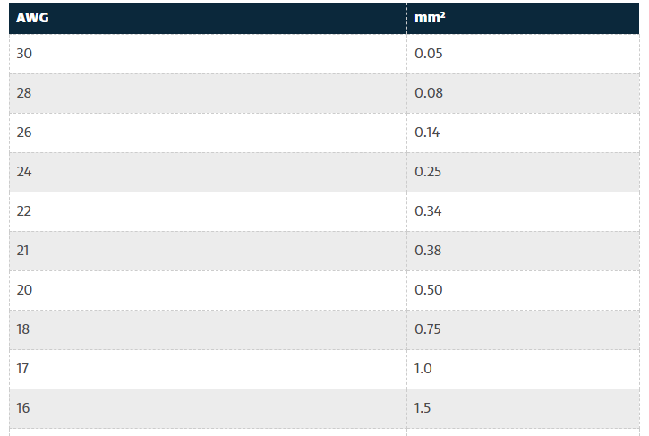
The AWG sizing chart in Figure 3.2 indicates a “20 AWG” for the cross-sectional area of .55 mm². Therefore, a gauge 20 wire will be needed to power the proposed end-effector. It is noted that customer requirements state the robotic arm must be powered by standard household appliance wall circuits. This will increase the complexity of electrical components powering the robotic arm components. The motors utilized in the design use a direct current (“DC”) power supply and the end effector specifications are alternate current (“AC”) power. Thus, additionally analysis of electrical components needed for the entire arm design is required.

    - Reliability of Bearings – Mica Nellis
Calculations regarding the bearings within this project are important because they must withstand long running times. It can be seen throughout this paper that many values to choose bearings were exaggerated in such a way that there is no viable way that they will fail during performance. Once values were chosen, they were inputted into GlobalSpec which in turn outputted tables with various important values that will directly affect this project, those tables can be seen within appendix A. Although those tables include all of the information that is needed to select an implement such bearings the reliability will also play a key role. Therefor the calculation for reliability was determined to be 0.945 or 94.5%, those calculations can be seen below.
Governing Equations:
$$x=\frac{L}{L_{10}}$$
$$R= \exp\left[-{\left(\frac{x-x_{0}}{θ-x_{0}}\right)}^{b}\right]$$
Calculations:
$$x=\frac{1.9*{10}^{6}}{{10}^{6}}=1891.6$$

$$R= exp⁡[-{\left(\frac{1891.6-0.02}{4.459-0.02}\right)}^{1.482}=0.945=94.5\%⁡$$

    - Linear Actuator – Russel Stringham
The calculations for the linear actuator were needed to ensure the actuator met the specifications needed for the robotic arm. These calculations were torque and stress. The stress calculation was to ensure the actuator supported the estimated arm weight. The arm's weight was estimated at 11 pounds and the rod's cross-sectional area was estimated to be 0.151 square inches. With these estimates the stress was 75.82 psi which was much less than the yield strength for Aluminum Alloy. Therefore, an actuator rod of that size or smaller will be able to support the weight of the robotic arm. The next calculation made was the torque that will allow the actuator to push the drill through the material. The next calculation for the actuator was to find the force required to meet the torque requirements for the drill. Based on Isaiah’s calculations the required torque for drilling through the material was XXXX. For the actuator the team estimated a stroke length of 10 inches. Therefore, the applied force required for the actuator is XXX. The equations for these calculations are listed below.
$F_{total} = F + F_{g}$ 1)
$σ = \frac{F_{total}}{A}$ (2)
$T = F × L$ (3)

Deformation – Daniel Cooke
In order to ensure that the maximum drilling tolerance of .003’’ is met, it was determined that the maximum allowed deflection for any part of the robotic arm should be .001 inches. This takes into consideration the material the main members are being constructed out of, as well as the shape and dimensions of those main members. This engineering analysis considers the deformation of 80/20 aluminum under various static loading. It will also compare the deformation of square tubing for the same length but for varying wall thickness. Table x shows the deflection of 80/20 aluminum as a function of loading. Figure x shows a plot of the deflection of square tube as a function of wall thickness at a constant static loading of 50 pounds.

Table 3.3: 80/20 Deformation Vs. Loading
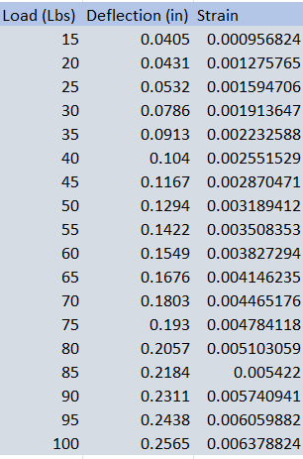
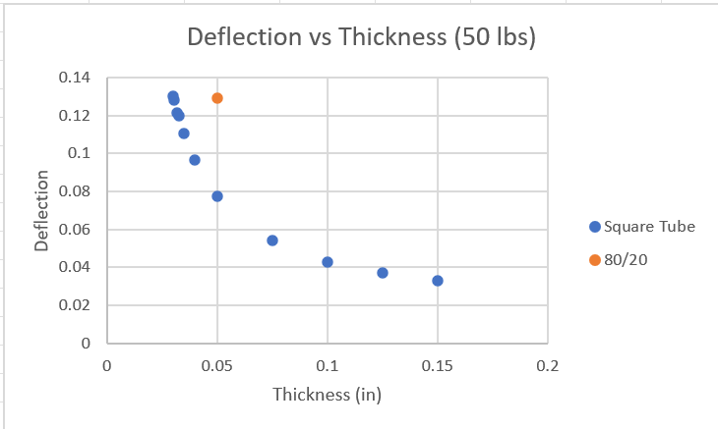
Figure 3.1: Deflection vs Wall Thickness
From this analysis it can be determined that a square tube with a wall thickness of .0303 inches will have near exact deformation characteristics as the 80/20 aluminum. Under a static loading of 50 pounds the 80/20 deformed .1294 inches, and the square tube with a wall thickness of .0303 inches deformed .01290 inches. This information will allow the team to model the square tubing within SolidWorks without needing the complex geometry of the 80/20 aluminum while still maintaining structural rigidity. In the case that the team needs to decrease either the weight or total cost od the product, the square tube is a more effective option.

4 Design Concepts

4.1 Functional Decomposition
Functional decomposition is a systematic process used in systems design and engineering where a complex system or function is broken down into its more manageable and simpler constituent sub-functions. This hierarchical approach divides a system into smaller parts or subsystems, which can then be designed, analyzed, and optimized independently before integrating them into the larger system. By doing so, functional decomposition helps designers and engineers understand the intricacies of the system, facilitates parallel work on different components, and aids in pinpointing potential problems or inefficiencies. Whether applied in software engineering, product design, or systems analysis, functional decomposition ensures that each individual component serves a specific purpose and contributes effectively to the overarching system goal. Figure 4.1 below displays the drill arm’s functional model.

Figure 4.1: Functional Model
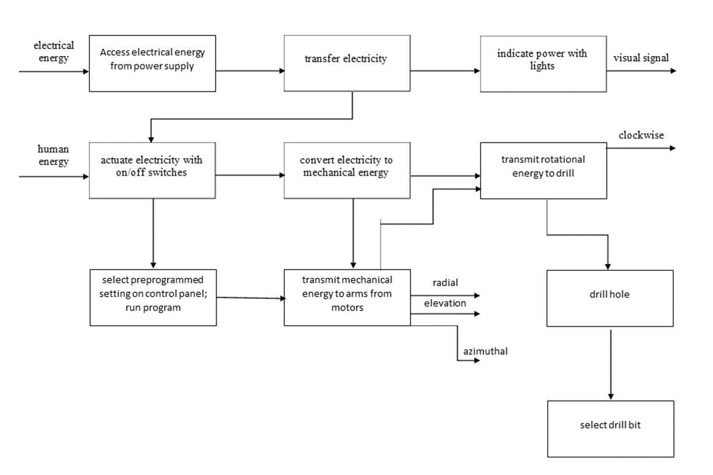

4.2 Concept Generation

4.2.1 Initial Process of Overall Drill Arm Concept Generation
The process of designing a robot drill arm involved a series of iterative concept generation phases, each driven by the team’s evolving understanding of the project requirements and the need to strike a balance between complexity, stability, and adaptability. This section outlines the key stages of concept evolution and the valuable insights gained from each iteration.

Initial Concept: Six Degrees of Freedom
The project’s inception saw the exploration of a six-degree-of-freedom robot arm design. The appeal of such a system lies in its high versatility and precision. However, as we delved deeper into the project, it became evident that this complexity surpassed our needs and budget constraints. This phase served as our introduction to servo motors and cycloidal drives, laying the foundation for our understanding of advanced robotic systems.

Transition to Scara Robot
In response to the realization that the six-degree-of-freedom design was excessive, the team pivoted towards a Scara robot configuration. This choice, while simpler, posed challenges in terms of stability, deflection, and drilling capacity. We gained valuable insights into moment arms, friction, and the limitations associated with the reduced degree of freedom. The Scara robot design, though ultimately discarded, served as a learning experience in optimizing the trade-off between simplicity and functionality.

Experimentation with Three Degrees of Freedom
A subsequent iteration involved a three-degree-of-freedom robot arm. While this design provided more stability compared to the Scara configuration, it introduced a new set of challenges. The geometry had to be redesigned for each change in the cylinder, making it impractical for a system requiring adaptability. This phase was instrumental in understanding the importance of adaptable geometry and its implications for drilling capacity.

Four Degrees of Freedom with Spherical Coordinates
After several iterations and the acquisition of a deeper understanding of our field of research, we settled on a four-degree-of-freedom robot arm design that operates using a spherical coordinate system. This configuration struck a balance between complexity and adaptability. The spherical coordinate system allowed for the required adaptability without the need for constant geometry redesign. Linear actuation and slew drives were employed in this final design, which served as a culmination of the lessons learned from the previous phases.
Final Design: Geometric Robotic Drilling Arm
The final design that the team has created is a geometric, four axis robotic drilling arm. Axis one will be the base axis of the robot allowing for movement left to right. The second axis will move the arm forward and backwards from its center controlling the lower half. The third axis will provide the robotic drilling arm with the ability to move in the x, y, and z direction allowing for vertical reach. The final and fourth axis is the end effector location allowing for “wrist” rotation.
In summary, each conceptual iteration in the development of the robot drill arm taught us valuable lessons and expanded our knowledge base. The six-degree-of-freedom robot introduced us to advanced motor and drive technologies, while the Scara design underscored the importance of stability and trade-offs. The three-degree-of-freedom robot emphasized adaptable geometry, the four-degree-of-freedom design proved to be closest to what the team wanted to design although it was much more difficult than what was needed. The final geometric robotic drilling arm incorporated the best aspects of our previous concepts, highlighting the importance of iterative design in complex engineering projects.

4.2.2 End Effector Material Composition – Isaiah Padilla
Selecting the appropriate drill bit material for drilling through aluminum is crucial for both the efficiency of the drilling process and the longevity of the drill bit. Aluminum, while softer and more malleable than many other metals, has certain characteristics that can pose challenges during drilling. For instance, aluminum tends to be “sticky”, often causing chips to adhere to the drill bit’s cutting edge, which can lead to a phenomenon called “built-up edge.” This not only reduces the efficiency of the drilling process but also results in subpar hole finish and potential damage to the workpiece.
Drill bits made from materials that have a high thermal conductivity can aid in dissipating the heat generated during the drilling process. This is vital when working with aluminum, as the metal’s high thermal conductivity can lead to excessive heat buildup, which may cause the material to soften and gum up the drill bit. On the other hand, drill bit materials with the right balance of hardness and toughness can resist wear and abrasion, ensuring a longer tool life and consistent performance. For example, while high-speed steel (HSS) drill bits are commonly used for drilling through aluminum because of their toughness, coatings like Titanium Aluminum Nitride (TiAlN) can further enhance their performance by reducing friction and improving wear resistance.

In summary, discerning the appropriate drill bit material for drilling through aluminum is not just about ensuring a clean and precise hole, but also about optimizing the tool’s lifespan and overall drilling efficiency. The right material choice can lead to reduced operational costs, minimized downtime, and a consistently high-quality finish on the drilled aluminum parts.

4.2.3 Power Transmission Concept Generation – Brandon Knutson
In the context of power transmission for our robot drilling arm, two primary methods have been explored: slewing drives and cycloidal drives. These methods each offer unique characteristics and advantages that significantly influence the functionality and performance of our robot drilling arm.
Slewing drives, known for their precision and versatility, have found applications in tank turrets and situations where a degree of freedom is limited to a single surface of rotation and is under compression. Noteworthy attributes of slewing drives include their high accuracy, making them suitable for applications requiring precise control, such as the precise positioning of a drilling mechanism on the surface of a cylindrical object. Additionally, slewing drives excel in generating substantial gear ratios, especially in larger configurations, which is invaluable for achieving the fine control required in our drilling arm. Their use of worm gears and helical gears enhances their performance and effectively prevents back transmission, a critical factor for ensuring stable and controlled drilling operations.
On the other hand, cycloidal drives bring an innovative approach to power transmission, utilizing pins and lobes to transfer power. They are characterized by their compact design, making them ideal for applications with space constraints. Their compactness is advantageous in shaping the overall design of our robot drilling arm. Moreover, cycloidal drives possess a remarkable ability to handle substantial torque, thanks to their unique construction. This feature is vital for a drilling arm tasked with penetrating the surface of a cylindrical object.
As we proceed with our design process, we will carefully assess the specific requirements of the robot drilling arm and weigh the advantages and limitations of slewing drives and cycloidal drives. Our ultimate decision will be guided by the need for precision, gear ratio, space constraints, and torque-handling capacity, all aimed at optimizing the performance and efficiency of the robot drilling arm.

4.2.4 Arm Concepts – Daniel Cooke
The robotic arm is potentially the largest source of deformation under the reaction load during the drilling operation. Therefore, it is essential that the proper material, shape, and dimensions of the arm are selected to minimize this deformation. A SolidWorks finite element analysis will give a good understanding of how different shapes and materials will deflect under loading. Ultimately, the goal is to be able to select the lightest possible material without sacrificing structural rigidity. The three shapes being analyzed are cylindrical tubing, square tubing, and an I-beam. The materials being analyzed are steel, aluminum, and polyacetal plastic.

4.2.5 Electrical Component Wiring – Mason Goodman
The concept generation for wiring components of the robotic arm is quite simple. Robotic arm designs can implement either internal or external wiring. The most important consideration with both concepts is limiting “loose” or “hanging” wires that can potentially snag on anything whilst the robotic arm performs functions. Given the fact that the arm of our current robotic design will be metal tubing, the team’s expectation is that most of the electrical wiring will be internal. Additionally, the stepper motors included in the design will be located near the base of the robotic arm, therefore wire housing or a simple zip-tie configuration can be utilized to effectively secure the wiring of major components as needed.

4.2.6 Bearing Concepts – Mica Nellis
Considering that bearings allow for less friction we will need to implement the perfect bearing due to the running time that is required by the clients. Two different types of bearings will be considered and be implemented, pillow block bearings as well as a turntable bearing that will be in the base of the robotic arm. The client recommended using these pillow block bearings because the team had thin section bearings which are not as durable. Although pillow block bearings will be used because of their durability and convenience to this design, using the flange bearing will also be explored once it is time to decide how these bearings will be mounted. The team must have a strong bearing in this design and given that many of the values that will directly impact the bearings used are not yet known these arbitrary values that were used allowed for the team to narrow down the type we will use in designing.

4.2.7 Linear Actuator – Russel Stringham
One of the concept sections the team had to decide whether to purchase or manufacture a linear actuator for the robotic arm. For purchase the main factors were quality and reliability will be better. In addition, if the design were complex, it would be easier to just purchase one. In building a linear actuator the price and custom ability were important upsides. The main downside was the time required to build such an actuator.

4.3 Selection Criteria

4.3.1 Selection Criteria for End Effector Materials – Isaiah Padilla
Selecting the appropriate material for drilling end effectors is crucial for optimizing their performance, longevity, and overall drilling efficiency. One of the key criteria in this selection is thermal conductivity. During drilling, significant friction is generated between the drill bit and the workpiece, leading to heat production. A material with high thermal conductivity is preferred for end effectors because it can quickly dissipate this heat, thereby preventing any localized overheating which might lead to premature wear or failure of the tool. Efficient heat transfer ensures consistent tool performance, reduced wear rate, and extended tool life.
Another vital criterion is the Brinell hardness value. The hardness of the end effector material should be higher than that of the workpiece to avoid wear and deformation. A material with a high Brinell hardness value indicates its resistance to indentation and wear. Using a harder material ensures that the end effector remains sharp and effective over extended periods, resulting in consistent drilling accuracy and fewer interruptions for tool replacements or maintenance.
Heat capacity also plays a role in material selection, although it is often considered secondary to thermal conductivity and hardness. A material with a high heat capacity can absorb and store more heat energy before its temperature rises significantly. This means that during prolonged or intensive drilling operations, the end effector will remain cooler for a longer period. When combined with good thermal conductivity, a high heat capacity ensures that the end effector can operate for extended periods without overheating, thereby enhancing its performance and lifespan. In summary, the interplay of thermal conductivity, Brinell hardness value, and heat capacity in material selection is pivotal in determining the efficiency, durability, and longevity of drilling end effectors.
4.3.2 Selection Criteria for Power Transmission Methods – Brandon Knutson
In the design of the robot arm, one of the critical decisions we had to make pertained to the selection of power transmission methods. The power transmission method at both the base and joints of the robot arm, particularly the wrist and shoulder joints, heavily impacting the arm’s performance, reliability, and overall functionality. To ensure a systematic evaluation, we established specific selection criteria for these two sets of circumstances, resulting in two distinct tables representing the criteria and their respective assessments. Tables 4.1 and 4.2 below display the selection criteria for the base and joints.
Table 4.1: Power Transmission Method Selection at the Base:
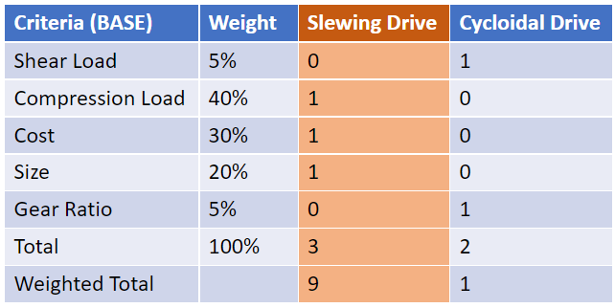
Table 4.2: Power Transmission Method Selection at the Joints (Wrist and Shoulder):
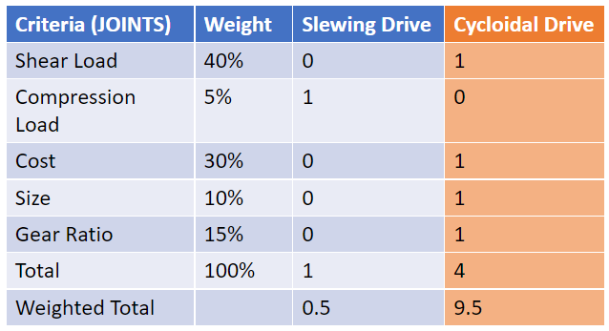
These tables provide a structured framework for assessing and comparing different power transmission methods for the base and joints of the robot arm. The criteria and assessments are instrumental in making informed decisions that align with the arm’s design objectives, performance requirements, and overall efficiency.

4.3.3 Arm Selection Criteria – Daniel Cooke
To determine the shape and material combination that deforms the least under load, a finite element analysis was performed using SolidWorks. An exaggerated load of x pounds was applied to the different arm configurations, and the resulting deformation was found from this analysis. As mentioned, the maximum allowable tolerance for all holes drilled on the internal surface of the cylinder is .003 inches (.0762 mm), so the desired maximum deformation of the main arm is .001 inches (.0254 mm). The results for the finite element analysis can be seen below in Table 4.3: Deformation of Main Arm Configurations.
Table 4.3: Deformation of Main Arm Configurations
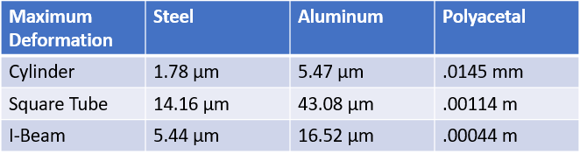

    - Wiring Selection Criteria – Mason Goodman
To determine the proper wire selection for the various components of the robotic arm design, students evaluated specifications tables for three different manufactured “continuous flex” wires. The selection criteria for respective wiring selection are listed below.
- Conductor Material – internal wiring material is important because various metals have different conductivity, or some materials can more efficiently move copious amounts of electrical current.
- Service Life – the service life of the wire based on manufacture specifications is one of the most important criterion. Industry standards show electrical components should be able to last a very number of cycles before replacement to reduce maintenance costs and machine down-time.
- Working Temperature Ranges – temperature ranges are important to consider as movement will increase wire temperature and electrical components should be able to in variable conditions.
- Cost – per foot price of respective wires is important for manufacturing cost of design.
The mentioned criteria will be utilized in a decision matrix to determine the best wiring for robotic – arm components. Table 4.4 depicted below entails the specifications for respective criteria based on manufacturer specification tables. Depictions of specification tables are included in the Appendix.
Table 4.4 – Wiring Selection Specification
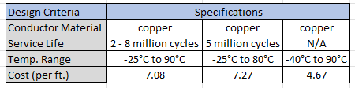

    - Bearing Selection Criteria – Mica Nellis
To select the proper bearing for the design, a few design criteria were considered, those being the max speed needed, max load on the bearings, the max base to center distance, and the max drill hole distance. Given that not all this information is fully known the values used were exaggerated in a way that makes it so the bearings that were looked at would not fail in this design. Those values used were:
- Max Speed = 1000 rpm/104.72 rad/s
- Max Load = 40 lbs/18.14 kgs
- Max Base-to-Center Distance = 2 inches/5.08 cm
- Max Drill Hole Distance = 5 inches/12.7cm
Using these different criteria and inserting them into a filter for pillow block bearings on GlobalSpec website there were two different bearings that could be used in this design.[6] Along with the output of those designs it showed all values and measurements to be considered in choosing these bearings and those can be seen in appendix A, the silver bearing is considered “Pillow Bearing 1” and the black is “Pillow Bearing 2” these will have their associated tables with them as well.

4.4 Concept Selection

4.4.1 Top-level Concept Selection – Brandon Knutson
We concluded that our custom design is the best suited for our project, using Table 4.5, displayed below.
Table 4.5: Concept Final Selection Results
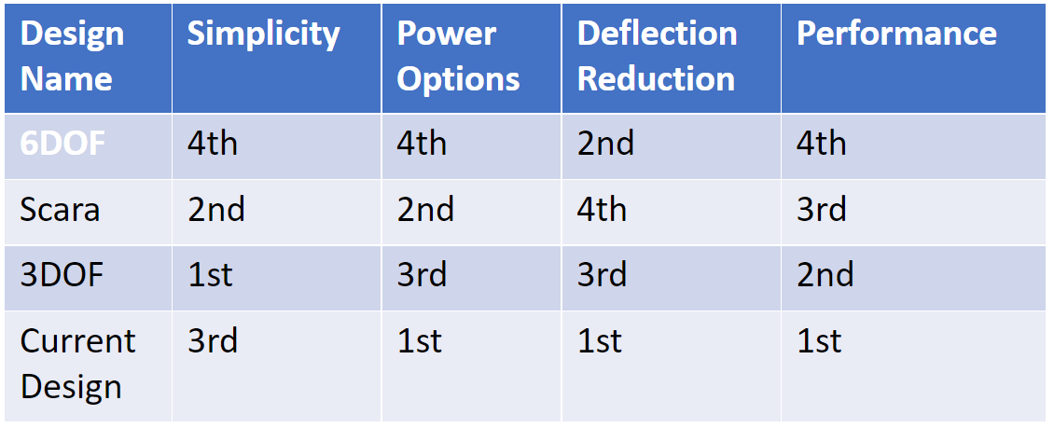
As this table shows, our current design is best suited for our project. However, it should be said that though they are not the best for our project all these designs have their pros and cons.

4.4.2 End Effector Selection – Isaiah Padilla
Cobalt, titanium aluminum nitride (TiAlN), and high-speed steel (HSS) are all materials or coatings used in the fabrication of cutting tools for various applications. When comparing these options specifically for drilling through aluminum, it is essential to consider their Brinell hardness values, heat capacity, and thermal conductivity. Table 4.6 below details the final selection results for the end effector material.

Table 4.6: End Effector Selection Table
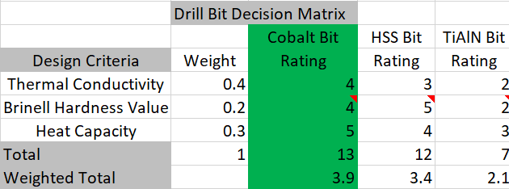
A comparison of the selected materials’ Brinell hardness values is performed below.
Cobalt: Cobalt tooling, often referred to as cobalt HSS or HSS-Co, is basically HSS with an added percentage of cobalt which enhances its hardness. This greater hardness makes it more resilient against wear, especially when machining abrasive materials like aluminum.
Titanium Aluminum Nitride (TiAlN): TiAlN is a coating, not a bulk material. While it provides impressive hardness and heat resistance when coated on tooling, it might not be the optimal choice for aluminum. The high hardness can sometimes result in the coating adhering to the aluminum, especially when drilling without proper lubrication.
High Speed Steel (HSS): HSS, while suitable for various applications, is softer than cobalt HSS. Its edge retention and wear resistance in abrasive materials like aluminum are inferior compared to cobalt.
A similar comparison of the heat capacities and thermal conductivity values is performed below.
Cobalt: Cobalt HSS tools are known for their ability to retain their hardness even at elevated temperatures. This is beneficial when drilling materials like aluminum, which can produce significant heat. The cobalt addition increases the tool’s red hardness, ensuring it performs effectively under heating conditions.
Titanium Aluminum Nitride (TiAlN): The coating excels at high-temperature operations, providing a layer that resists heat. However, when drilling aluminum, which tends to be gummy and stick to the tool, the heat can cause the aluminum to adhere to the TiAlN coating.
High Speed Steel (HSS): While HSS can effectively dissipate heat, it does not retain its hardness as well as cobalt HSS when exposed to elevated temperatures.
In conclusion, when drilling through aluminum, cobalt (HSS-Co) proves to be the superior material when compared to standard HSS and TiAlN-coated tools. Its enhanced Brinell hardness value ensures longer tool life and resistance to wear, while its improved heat capacity and thermal conductivity attributes make it effective in managing the heat produced during the drilling process. The combination of these factors ensures optimal performance and longevity when using cobalt tools for aluminum applications.

4.4.3 Power Transmission for Power Transfer – Brandon Knutson
Following a comprehensive evaluation of power transmission methods for our robot drilling arm, we have made a judicious decision regarding the configuration that best aligns with our project’s objectives and requirements.
After careful consideration, we have opted to employ a slewing drive for the base of the robot drilling arm, while implementing cycloidal drives for the shoulder and wrist joints. This choice is driven by a nuanced understanding of the advantages and characteristics of each transmission method, and how they align with the specific demands of our project.
The slewing drive, characterized by its high precision and substantial gear ratio, is well-suited for the base of the robot drilling arm. The precise positioning and control it offers align perfectly with the need for accurate alignment and stability when the drill engages with the cylinder’s surface. Additionally, the combination of worm gears and helical gears in the slewing drive ensures secure and controlled rotation, preventing unwanted back transmission.
On the other hand, the compact design and high torque capacity of cycloidal drives make them an ideal choice for the shoulder and wrist joints. These joints require flexibility, adaptability, and the ability to withstand significant torque, characteristics that the cycloidal drives excel at providing. Their compactness is also advantageous in preserving the overall space and maneuverability of the robot drilling arm.
Our decision to combine these two transmission methods optimally balances precision, gear ratio, space constraints, and torque-handling capacity, all while considering the specific needs of the various arm components. This configuration allows us to harness the strengths of each transmission method, creating a robot drilling arm that can perform with accuracy, stability, and versatility.
Moving forward, we will proceed with the detailed design and implementation phases, ensuring that the chosen power transmission configuration is integrated seamlessly into the overall structure of the robot drilling arm, while adhering to our project’s objectives and performance expectations.

4.4.4 Arm Concept Selection – Daniel Cooke
As a result of the decision matrix displayed in Table 4.7, the chosen main arm design is a cylindrical tube made from polyacetal plastic. Although plastic deforms the most out of the material options, it is much lighter, cheaper, and less susceptible to galling than the other materials. The cylinder is the most structurally rigid shape, and it allows for the internal storage of wiring and other components. Future research and calculations will be conducted to determine the cylinder diameter, shell thickness, and necessary length of the arm. Increasing the diameter and thickness will decrease the amount of deformation the arm will undergo.

Table 4.7: Arm Concept Selection
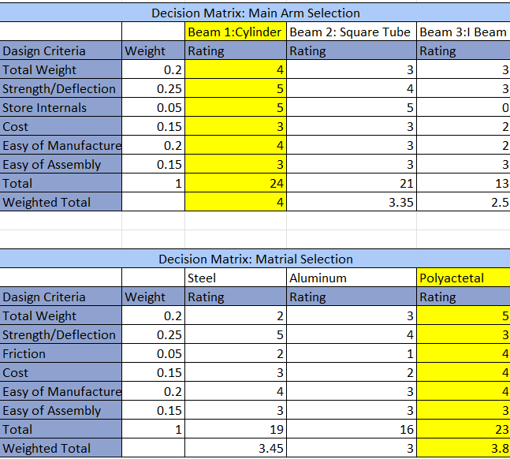

4.4.5 Wiring Selection – Mason Goodman
The wiring selection process utilized a decision matrix to decern the best selection for high-flex component wiring of the robotic arm. The criteria developed in section 4.3.5 were weighted and based on the specifications in Table 5.8 were ranked on a scale of one to five. The weighted total was then calculated, and the results are shown below in Table 4.8.

Table 4.8: Wiring Decision Matrix
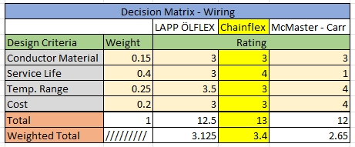

Preliminary design expectation was to utilize linear actuators in unison with the end effector to create the robotic arm movement the customer needs required. Therefore, the end-effector, linear actuators, and motors required to run the components were identified as “high-flex” components in which the included wiring would need to be adjusted to account for the continuous wear the cheaper wiring would experience. However, team design iteration has simplified the design to utilize a pully or chain system along with motors positioned at the base to accomplish robotic arm movement. Therefore, the only component that has been identified as “high flex” in the current design is the end-effector. Overall, this simplifies the electrical wiring components of the robotic arm design.

4.4.6 Bearing Selection – Mica Nellis
For choosing which bearing would be best for this design a few different criteria were implemented, total weight, max speed, max load, and drill hole distance. Implementing these into the table below and giving a raw score and a weighted score, pillow bearing one will be the best option for the team’s drilling arm. Although this bearing did not surpass pillow block bearing two by much, the only idea that made the chosen bearing better is its design and style. It is quite bulky, which is not ideal for the team’s design. Table 4.9 displays the bearing option comparisons.
Table 4.9: Comparison of Bearing Options Against Constraints
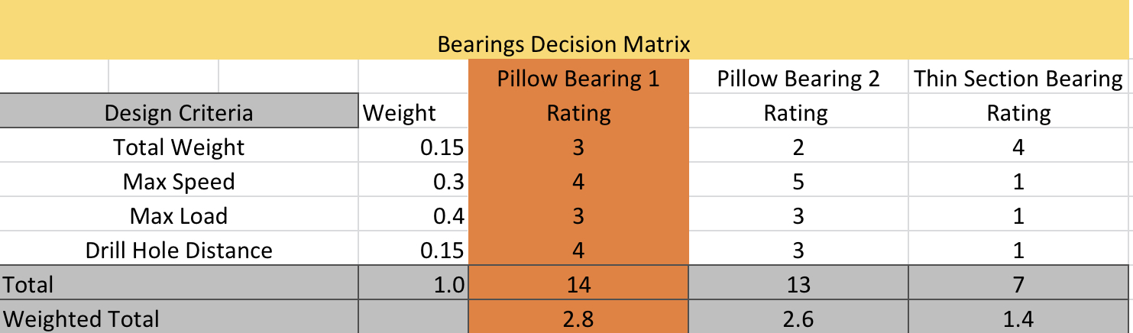
Table 4.10: Comparison of slewing drives and slewing bearings
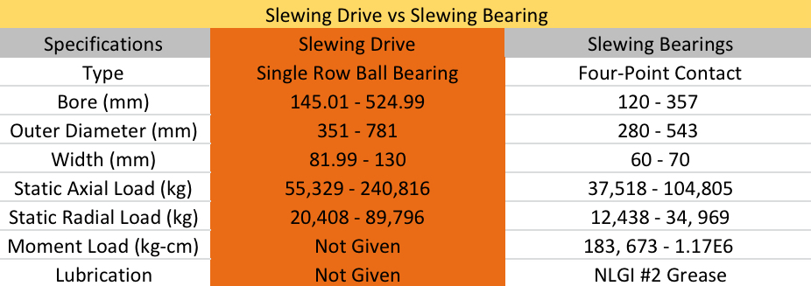

You can see above a decision matrix between a slewing drive and a slewing bearing for the movement of our base. The team wanted to narrow it down to these two things because they are the few options that will give the robotic arm enough torque to rotate with the accuracy that is required. Overall, both of these options were extremely similar but the choice of a slewing drive to save time as well as not having to create a customized part.

4.4.7 Linear Actuator – Russel Stringham
Based on the design matrix below in Table 4.11, it was determined that the team should build their own linear actuator. It was influenced mostly by the price and customization of the actuator. In doing so the team will be able to manufacture an actuator that can fit exactly for the robotic arm for a cheaper price. This will allow for more money to be spent on other important parts, like the motors. If the team finds a company that would be willing to donate an actuator that will be the best alternative.
Table 4.11: Design Matrix – Linear Actuator
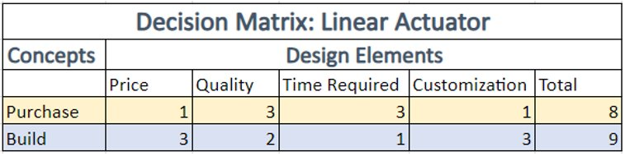

5 Schedule and Budget

5.1 Schedule
Figure 5.1 below displays the Gantt chart for this first semester’s work efforts. The first phase of the project, outlined in blue, saw the team completing relatively simple taskings such as initial research, breaking up into sub teams, creating the tasking for the team itself, and completing the team charter. Once these were completed, the team moved onto more complex taskings such as the quality function deployment (QFD, where the team decided how to transform the client’s requirements into engineering requirements as well as prioritizing which ones needed to have a higher importance than others), the Gantt chart (where all of these taskings were listed and described alongside their respective due dates, timelines, and completion statuses), parts and literature research (an further round of research into parts and any literature which may be of interest to the team), budget planning (where the team decided how to best apply our given funds to the project), and the first presentation (where the team presented its initial efforts in research and simple calculations that were performed). Staff meetings and peer evaluations, where the team came together to discuss updates, next steps, and any changes that needed to be made to each member’s respective end of the project, as well as provide feedback for one another at periodic points throughout the semester. Client meetings also occurred on a biweekly basis for the purpose of giving our main points of contact with our client updates on the project on whatever work the team had completed within each set of two weeks. It should be noted that staff meetings, peer evaluations, and client meetings were regularly repeated with little change in how each of these taskings worked, so further reporting on each of these taskings will be omitted in following descriptions of each phase of the project.

Figure 5.1: First Phase of the Project

Figure 5.2, shown below, displays the second phase of the project, as highlighted in red. This second phase saw the team starting the initial set of Computer Aided Design (CAD) work on a prototype, order the first set of parts for a prototype, and design a website to be updated throughout the semester for the team containing multiple pages including a home page, about us section, documentation, gallery, team listing, and project description, as well as a page with information on how to contact members of the team. A client presentation was eventually conducted, though due to time constraints of the client, the presentation wouldn’t actually be presented until close to the end of the third phase of the project. This presentation gave the clients a complete update on what the team was doing to solve their problem, as well as showing them all the progress that was made, what considerations are being taken, and how risks are being mitigated. Parts research continued and ended late in the phase cycle, with prototype parts being ordered alongside the end of that research such that the team could construct its first prototype. The first team report was created, containing a total summary of every single piece of work completed by the team up to that point in time, including a project summary and description, calculations, literature review, schedule, CAD work, Bill of Materials, QFD, functional diagram, black box diagram, budget updates, and any other relevant information. The analytical analysis memo was dedicated to helping team members come up with their own ideas on how to conduct separate sets of calculations to be performed such that they could mathematically prove other parts of the current design, to be completed in a later assignment. The second presentation was essentially an update to the first, providing all updated information and efforts in the project, alongside any new calculations and literature review efforts.
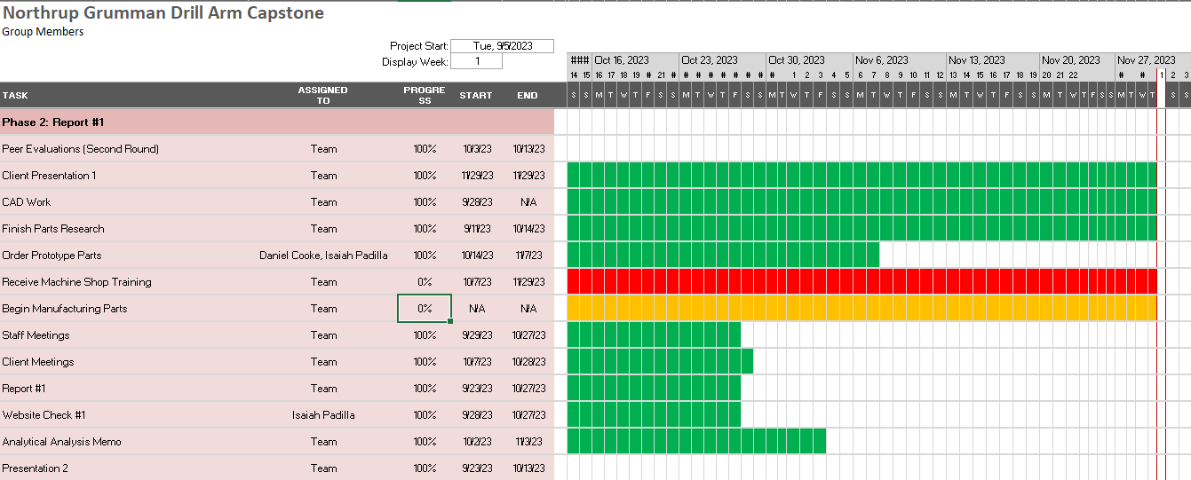
Figure 5.2: Second Phase of the Project
Figure 5.3, shown below, displays the third and final phase of the first semester’s work effort. The first prototype built by the manufacturing sub team was presented in class to display a working robotic arm. The bill of materials and final CAD efforts were also completed together for the final prototype, which was also designed to be scalable so the team could use it for the final product. The final prototype assembly and demo, which aren’t complete at the time of writing but soon will be, will be presented in class to fellow teams for constructive feedback. The project management assignment will act as a review for both this semester and an outline for how the team can set itself up for success next semester. A second website check will be performed to see how the team’s website is coming along. This will provide an opportunity to see whether the website has sufficient material on it and looks presentable. A second team report was also completed involving further updates and calculations, as well as additional literature review elements and the final CAD and Bill of Materials efforts.
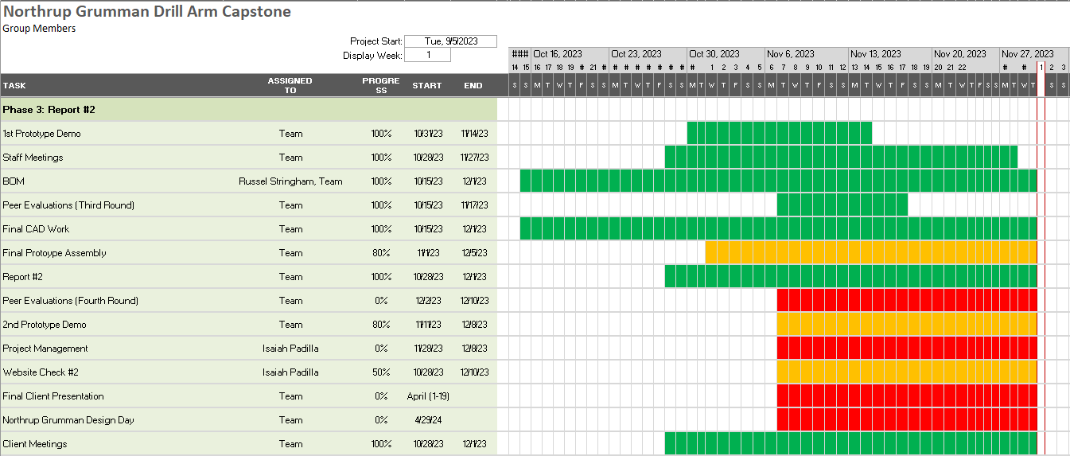
Figure 5.3: Third Phase of the Project

Figure 5.4 below displays a rough draft outlining the work to be performed during the second semester. This fourth phase, highlighted in orange, shows the basic taskings for next semester, including the staff and client meetings as well as the peer evaluations. However, much of the work involves getting the team certified to use machine shop tools to manufacture parts based on the CAD work performed by the team. A final product demonstration will be completed both in class and during the client’s presentation day (Northrop Grumman’s Design Day, in this case). Testing efforts will need to be conducted following the completion of the product assembly. An individual self-learning assignment will also be given to the team at some point, though at this time it is unknown what the focus will be. Any revisions to the CAD package assembled by the team will need to be made throughout the semester as needed. The final report alongside a corresponding poster will need to be assembled and created for use on the client’s presentation day. Two more website checks will be conducted to ensure that the development of the website is going well. A specification sheet, operation, and assembly manual will need to be assembled by the team for the client to be able to use on their own, which will be given to the client during the handoff following the final presentation.
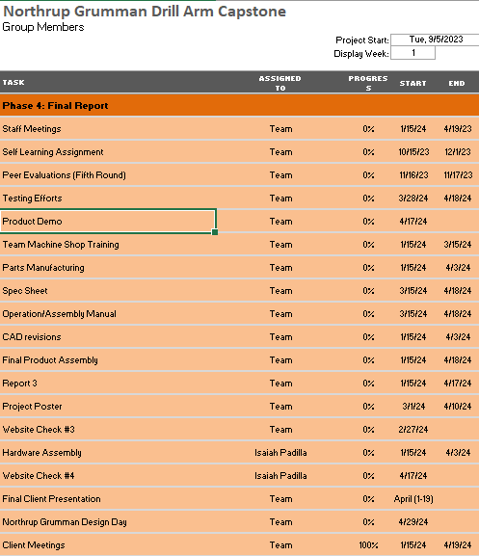
Figure 5.4: Fourth Phase of the Project

5.2 Budget
The project budget supplied by Northrop Grumman at the current stage of the design is $5000. Therefore, capstone requirements state the team must fund raise 10% or $500 dollars to meet emergency fund requirements. To retain the full budget provided by Northrop Grumman for full-scale design the team self-fund raised $300 for prototyping purposes. Figure X depicts the total costs of the full-scale robotic arm designed by the team, as well as a section included for prototyping costs.
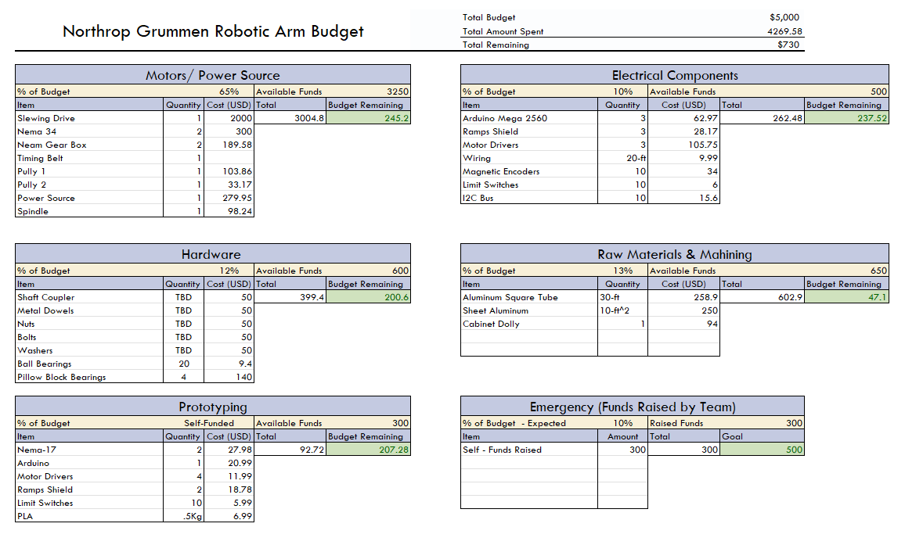
Figure 5.5: Team Budget

5.3 Bill of Materials (BoM)

The bill of materials is located within Appendix C.

6 Design Validation and Initial Prototyping

6.1 Failure Modes and Effects Analysis (FMEA)
Within the team’s FMEA which can be referenced within Appendix B there were several components of this design that would cause major problems or failures. Within the electrical components of our design the potential of the motors overheating will contain the most risk with an RPN of 315, to mitigate this the team is going to adjust the motor driver as well as the current input pull.
Following this the member assembly and hardware also poses an enormous risk for the team; all main members have potential inelastic bending or loss of position. To prevent this bending within the main members of the design the team will use the strongest material possible within reason, along with that preventing the loss of position can be modified by ensuring all members are appropriately spaces as well as aligned properly.
Theiablel slewing drive assembly may have potential failure with the motor driving it as well as the bearing within it. To ensure the motor driving the slew bearing does not overheat the team plans to prevent excess current running through so there is an appropriate life cycle to fulfill the required running time. The slewing bearing simple needs proper lubrication to prevent the potential seizures it may have.

6.2 Initial Prototyping

6.2.1 Physical Prototype 1
For this physical prototype there were a few goals the team wanted to achieve to set the team up for future prototypes and the final design. It was important to understand the functionality of 2D kinematics for the whole system. In addition, determining the required bearing surfaces for current locations throughout the model. For the motors running in this prototype, the team wanted to know the holding torque and torque-speed characteristics for the second prototype. Also understanding the gear box output requirements. By assembling the prototype and running the test, the team wanted to find any inferences with parts. This will allow for the desired range of motion. Overall, the goal of this prototype was to set the team up for a strong second prototype and final product.
After the completion of physical prototype one, most of the questions the team had before were answered. The 2D kinematic function of the robot was answered and there were little inferences between the different parts. In addition, the desired range of motion was reached for a prototype, which is scaled down. Therefore, the full-scale model will be able to reach the desired hole locations as well. The team found that all contact surfaces will require bearing, that will be incorporated in the second prototype. For level arm, the team found that adding a counter-weight aids in actuation of the end effector. And finally, the team found that a gear box with at least a five to one gear ratio will be required to increase torque output. Based on these findings, the next step is to incorporate those in the second prototype to ensure the finds were correct and see if there is any other issue that comes up. The focus when creating the next prototype is designing gear boxes and having a better understanding of the Arduino electrical components and the code.

6.2.2 Virtual Prototype 1
The virtual prototype was used to answer the simple question of “will this design move the way the team desires?”, by using the motion study option within SolidWorks the team was able to see just how the robotic drilling arm would move. The team was able to rotate and adjust angles accordingly to see what would happen within the CAD assembly. By showing the vertical reach as well as the rotation, the hope was that the assembly would stay together and not break any mates within SolidWorks.
After the completion of this motion study, it was obvious that the design within SolidWorks was not complete, the team needed to make several adjustments to create a robotic drilling arm that was up to the standards of what was required. The motion study showed various breaks within the mates when trying to adjust the angle that the end effector would reach which is a major issue within the design.
To adjust and fix these different elements within the design to not have as many issues and be more like the finished product it was necessary to adjust all linkage systems within the design as well as the base of the design. The hope for the team is to create a base that is not nearly as big as well as have the addition of bearings and plates that will better hold the entire design together. The team wants a base that is sufficient enough to hold a slewing drive within it to have enough rotational power to rotate the entire robotic drilling arm. Following that with the addition of these plates and bearings there should be no breakage within the linking of all the “arms” within this robotic drilling arm. Overall, the first prototyping process helped the team to plan for future prototyping as well as the final design in hopes that we will complete the competition with success.

6.3 Other Engineering Calculations
6.3.1 Holding Torque for Motors
This additional engineering calculation was needed in gaining a better understanding of the holding torque requirements for the motors for the final design. The holding torque of the motor ensures that the arm will stay in place when drilling into the cylinder. The calculation done was for the arm at full extension which will create the greatest torque needed for the motors to hold. If the holding torque is not strong enough the arm could bounce when moving from one point to another. Also keeping a small enough tolerance for the drilling hole. The assumptions made were an estimated weight of the arm to be 25 kg and the distance to the center of mass to be 0.3048 m. These measurements will change due to the material of the arm and the additional weight of the end defector drill. The total torque applied to the motor was a combination of the torque applied and the torque due to gravity. With those assumptions and the equations listed below the total torque that the motors will need to hold will be 733.1 Nm.
$$τ_{applied} = F×L$$
$$τ_{g} = m×g×r$$
$$τ_{total} =τ_{applied} + τ_{g}$$

6.3.2 Power Supply Needed for Prototyping
The prototypes for the Robotic arm design provide proof of concept for robotic arm members as well as arm design movement. Students utilized Nema-17 motors to provide movement in the X and Y planes. Nema-17 motors require a 24-Volt DC power supply and are stated to pull a maximum of 2-Amps for the rated torque. The power supply needed to be able to supply the total max current poll for robotic arm movement. Additionally, it should be able to supply additional amperage given spikes to stalling loads the motors themselves may encounter. The specification table of the Nema-17 purchased was utilized to determine the electrical requirements for each respective motor. It was found through power calculations that the power supply needs to have a 5.6-Watt capability as well as an amperage rating of 4-Amps. Professor Willy has supplied the team with a power supply that meets these specifications and will be utilized throughout the remainder of the prototyping process.
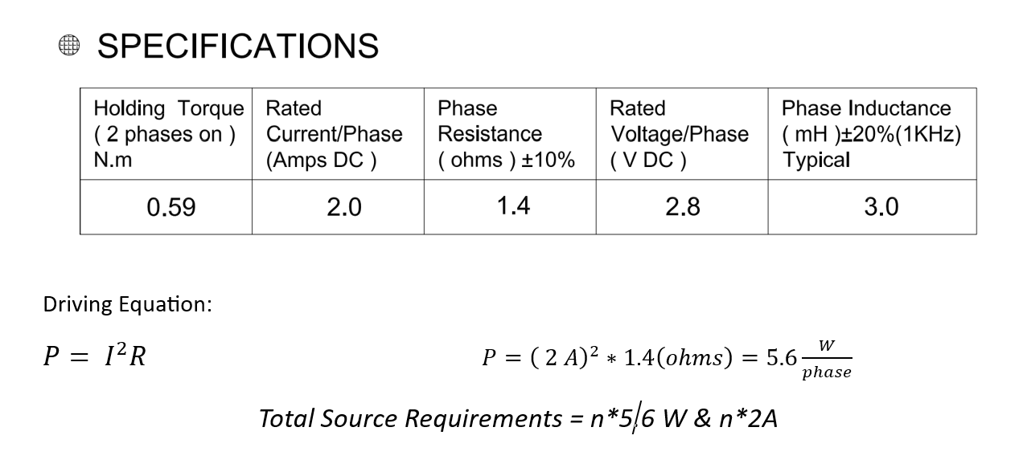

6.4 Future Testing Potential
Northrop Grumman has tasked students with creating a Verification Matrix that details testing procedures regarding how the Customer and Engineering Requirements of the experiment will be accomplished. The team has identified seven crucial validation requirements that are essential to project success. Table X includes the activity, objective, and method the team will implement to complete respective requirement designations. The phases included within the table identify a timeline congruent with Northrop Grumman presentations and have been implemented into the Ghant Chart for the second semester of Capstone. The team will integrate the validation requirements of Northrop Grumman with iterative prototyping requirements of the design class moving forward.
Table 6.1: Validation Process Moving Forward
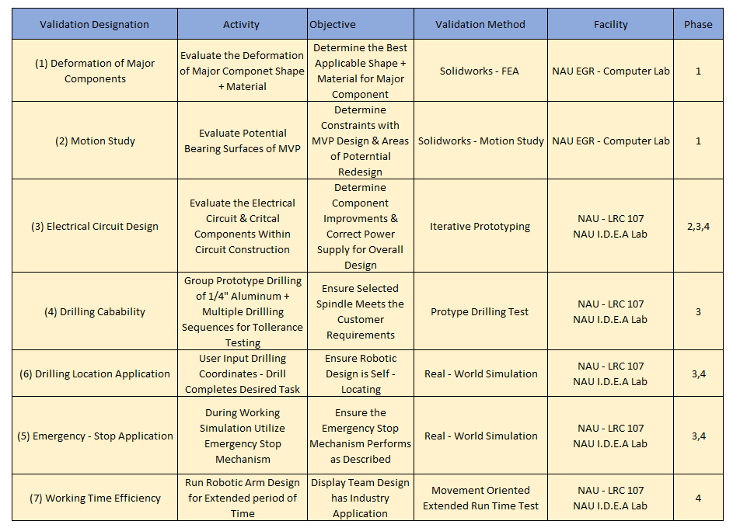

7 CONCLUSIONS
In summary, this team is going to create a robotic drilling arm for Northrop Grumman Space Systems to help aid in drilling secondary structures for the launch vehicles their company designs. For the team to fully accomplish the assigned task, it was decided that creating a robotic arm with different bolt clearances, specific dimensions, and being fully autonomous was necessary. In doing this the team has also decided to use a reliable drilling system to have enough force to drill the composite material that these cylindrical components are made of within the competition, that being aluminum. The total budget will have a high impact on what we design but given the flexibility that Northrop Grumman has allowed as can be seen throughout this paper, the team has made design choices that will ensure we stay within the maximum allotted $10,000. The team’s fundraising is already in motion with our budget manager reaching out to several different companies in hope of receiving positive answers, suggestions, and resources. Knowing how important this design can be for Northrop Grumman the team will be putting in the maximum amount of effort towards our success, the team wants to have a fully functional and state of the art design ready to present at Northrop Grumman Design Day.
The final design took time for the team to decide on as more Information was discovered through mathematical modeling, benchmarking, customer constraints, engineering requirements and meeting with the clients. The team began thinking that it was necessary to design a robotic arm that included degrees of freedom, only to discover that this was much more complex than what was needed to succeed in the overall design. Following this the team also thought of designing a robotic arm that was similar to a Scara Robot which posed issues within deflection and accuracy, thus moving to a robotic arm with three degrees of freedom which in turn made it so the teams design could not adapt to the challenges it may face during day-to-day use. Reaching the team’s design of a four-degree freedom robotic drilling arm with spherical coordinates. This design was great for the team at first but after careful consideration the linear actuators within this design were not practical given the knowledge the team has as a whole. After several different iterations of this design were considered mathematically impractical. The team’s final design will have a balance between complexity and adaptability, which is imperative to the functionality of the team’s design. The final design, being geometric, will likely be the simplest design up to this point and will also be the most successful.
Up to this point in the design process the team is on the right track to succeed in this design and will continue to adapt and change design choices to make the best robotic drilling arm possible. It is likely that the team will have to make choices within designing that may prove to be difficult and even make choices that are unnecessary but with that the team has an excellent design that has been shown to the clients and has been given their approval. This design will complete all that it is tasked with, having enough force, accuracy, and power to meet the constraints that have been put onto it. The team is very hopeful that this design will continue to be the best possible choice for what the client needs to potentially use this in house and most importantly succeed in Northrop Grumman Design Day.

8 REFERENCES
[1] R. G. Budynas and J. K. Nisbett, “Chapter 9 – Welding, Bonding, and the Design of Permanent Joints,” in Shigley’s Mechanical Engineering Design, 11th edition, SI units, 11th ed, S.l., NY: MCGRAW-HILL EDUCATION (AS, 2020, pp. 485–612
[2] R. G. Budynas and J. K. Nisbett, “Chapter 4 – Deflection and Stiffness,” in Shigley’s Mechanical Engineering Design, 11th edition, SI units, 11th ed, S.l., NY: MCGRAW-HILL EDUCATION (AS, 2020, pp. 173–219
[3] G. R. Reddy and V. K. Eranki, “Design and Structural Analysis of a Robotic Arm,” thesis, Karlskrona, 2016
[4] R. Gautam, A. Gedam, A. Zade, and A. Mahawadiwar, Review on Development of Industrial Robotic Arm. International Research Journal of Engineering and Technology, 2017
[5] X. Zhang, M. Huang, M. Lei, H. Tian, X. Chen, and C. Tian, “Improved Rapid-Expanding-Random-Tree-Based Trajectory Planning on Drill ARM of Anchor Drilling Robots,” Machines, vol. 11, no. 9, p. 858, Aug. 2023, doi: 10.3390/machines11090858.
[6] M. Fairchild, “Drilling robots: Automate for fast and precise results,” #HowToRobot, https://howtorobot.com/expert-insight/drilling-robots (accessed Sep. 15, 2023).
[7] T. Xometry, “Drilling machines – parts, types, and uses,” Xometrys RSS, https://www.xometry.com/resources/machining/drilling-machines/ (accessed Sep. 15, 2023).
[8] R. Cheaytani, “Choosing the right drill bit,” Buying Guides DirectIndustry, https://guide.directindustry.com/choosing-the-right-drill-bit/ (accessed Dec. 1, 2023).
[9] A. Tyurnina, “Drill bit selection,” Inrock, https://www.inrock.com/drill-bit-selection/ (accessed Dec. 1, 2023).
[10] M. Lynch, “5 tips for selecting the optimal Spindle Range,” Modern Machine Shop, https://www.mmsonline.com/articles/5-tips-for-selecting-the-optimal-spindle-range (accessed Dec. 1, 2023).
[12] “ENGINEERING MECHANICS: Dynamics” by R. C. Hibbeler (2018) [8]: This comprehensive textbook provided foundational knowledge in engineering mechanics and dynamics, which served as a crucial reference for understanding the principles behind mechanical systems and their behavior.
[13] “Shigley’s Mechanical Engineering Design” by R. G. Budynas, J. Keith Nisbett, and Joseph Edward Shigley (2020) [9]: This authoritative text on mechanical engineering design was a valuable resource for gaining insights into mechanical component design, materials, and machine elements.
[14]”Laser Drilling of Composite Material: A Review” by K. F. Tamrin, N. A. Sheikh, and S. M. Sapuan (2019) [10]: This paper, which reviewed laser drilling of composite materials, offered insights into cutting-edge technologies relevant to the drilling aspects of the robot arm.

[15] “Software Interfacing of Servo Motor with Microcontroller” by A. Haidar, C. Benachaiba, and M. Zahir (2013) [11]: This paper discussed the interfacing of servo motors with microcontrollers, providing essential information for the development of the robot’s control system.
[16] “Inverse Kinematics Analysis Trajectory Planning for a Robot Arm” by G.-S. Huang, C.-K. Tung, H.-C. Lin, and S.-H. Hsiao (2011) [12]: This research on inverse kinematics and trajectory planning was vital for understanding how to control the robot arm’s movement with precision.
[17] “RoboDK – Simulator for Industrial Robots and Offline Programming” [13]: The RoboDK simulator was a practical tool that allowed for offline programming and simulation of robot movements. This online resource aided in testing and refining control algorithms.
[18] “Jeremy Fielding – All Things Mechanical” [14]: Jeremy Fielding’s website provided insights and practical knowledge related to mechanical engineering, which was beneficial for the design and construction of mechanical components within the robot arm.
[19] “RCTESTFLIGHT” [15]: This online resource offered insights into various aspects of robotic technology and flight systems, serving as an informative reference for understanding the intricacies of robotic systems.
[20]”How Does a Cycloidal Drive Work?” by tec-science (2019) [16]: Tec-science’s explanation of cycloidal drives was essential for understanding power transmission mechanisms and their potential applications in the robot arm.
[21] R. G. BUDYNAS, “Gears- General,” in Shigley’s Mechanical Engineering Design, 11th ed, MCGRAW-HILL EDUCATION, 2019
[22] W. D. Callister and D. G. Rethwisch, “Mechanical Properties of Metals,” in Materials science and engineering: An introduction, 10th ed, Milton, QLD: John Wiley and Sons Australia, Ltd, 2021
[23] T. J. Baumeister, E. A. Avallone, and T. I. Baumeister, Standard Handbook for Mechanical Engineers, 7th ed. New York: McGraw-Hill Book, 1978.
[24] A. Bicchi and G. Tonietti, “Fast and ‘soft-arm’ tactics,” IEEE Robotics &amp; Automation Magazine, vol. 11, no. 2, pp. 22–33, 2004. Doi:10.1109/mra.2004.1310939
[25] S. G. Yakovlev, J. K. Keldibekov, and I. M. Gorbachenko, “Software development for 3D visualization of G-code when working with CNC machines,” Journal of Physics: Conference Series, vol. 1515, no. 2, p. 022082, 2020. Doi:10.1088/1742-6596/1515/2/022082
[26] “What is manufacturing & Manufacturing Processes,” Engineering Product Design, https://engineeringproductdesign.com/knowledge-base/manufacturing-processes/ (accessed Sep. 17, 2023).
[27] “Browse Catalog,” McMaster-Carr, https://www.mcmaster.com/ (accessed Sep. 17, 2023).
[28] T. Seo, G.-P. Jung, and D. Yun, Advances in Bio-Inspired Robots. S.l. Units: MDPI AG, 2021. Journals/Articles
[29] “Speed – torque curves for Stepper Motors,” Oriental Motor U.S.A. Corp., https://www.orientalmotor.com/stepper-motors/technology/speed-torque-curves-for-stepper-motors.html (accessed Nov. 29, 2023).
[30] B. J. Goodno and J. M. Gere, “Chapter 8: Deflection of Beams,” in Mechanics of Materials, vol. 11th, Australia: Cengage, 2021

[31] Chapter 11 – Implementation, in Engineering by design

[32] Development of Robotic Arm Prototype – A. Chaudhari, K. Rao, K. Rudrawar, P. Randhavan and P. Raut,

[33] A Review of Current Techniques for Robotic Arm Manipulation and Mobile Navigation – T. Sieusankar and B. Chandrasekaran, T. Sieusankar and B. Chandrasekaran

[34] Design of Geometric-Based Inverse Kinematics for a Low-Cost Robotic Arm – M. A. Muslim and S. N. Urfin

[35] The Demeter Project – How to Create a Robotic Arm With Your Students

[36] “Simplify Robot Programming with G-code – Universal Robots,”
[37] “Appendix E: Creating the validation plan with a validation requirements matrix,” NASA, https://www.nasa.gov/reference/appendix-e-creating-the-validation-plan-with-a-validation-requirements-matrix/ (accessed Nov. 29, 2023).
[38] P. Eskofier, “Drv8825 Adjust stepper current,” my home fab, https://www.my-home-fab.de/en/documentations/technical-descriptions/drv8825-adjust-stepper-current (accessed Nov. 14, 2023).
[39] “Three golden rules for choosing a power supply (no maths!) – tutorial iableia,” Core Electronics, https://core-electronics.com.au/guides/power-supply-which-to-choose/ (accessed Nov. 29, 2023).
[40] R. G. Budynas and J. K. Nisbett, “Chapter 5- Failure Resulting from Static Loading,” in Shigley’s Mechanical Engineering Design, 11th edition, SI units, 11th ed, S.l., NY: MCGRAW-HILL EDUCATION (AS, 2020, pp. 241-275)
[41] R. G. Budynas and J. K. Nisbett, “Chapter 18 – Power Transmission Case Study,” in Shigley’s Mechanical Engineering Design, 11th edition, SI units, 11th ed, S.l., NY: MCGRAW-HILL EDUCATION (AS, 2020, pp. 937-953)
[42] A. Imran and B.-J. Yi, “Performance Analysis of 7-DOF Robotic Arm for Drilling and Milling Applications,” Performance Analysis of 7-DOF Robotic Arm for Drilling and Milling Applications, Jun. 2018, doi: 10.1109/urai.2018.8441826.
[43] Garnier, Sebastien & Subrin, Kévin & Waiyagan, Kriangkrai. (2017). Modelling of Robotic Drilling. Procedia CIRP. 58. 416-421. 10.1016/j.procir.2017.03.246.
[44] Jinho, Lee & Hong, Taehwa & Seo, Chang-Hoon & Jeon, Yong & Lee, Moon & Kim, Hyo-Young. (2021). Implicit force and position control to improve drilling quality in CFRP flexible roboticmachining. Journal of Manufacturing Processes. 68. 1123-1133. 10.1016/j.jmapro.2021.06.038
[45] “DatasheetDirectory,” Globalspec.com,2020. https://www.globalspec.com/specsearch/partspecs?partId
[46]“ThinSectionBearingsforIndustrialRobotsRBCThinSectionBallBearings:BecauseThat’sHowWeRoll.IndustrialRobotApplications:•HumanAssist•Medical•Paintspray•Pickandplace•Semiconductor-Vacuum -Atmos pheri c • Wel ding.” Accessed: Oct. 09, 2023. [Online]. Ava iable: https ://www.rbcbearings.com/literature/pdfs/ThinSect_Ro bots_3_28_16.pdf

[47]“PillowBlockBearinginSolidWorks,”www.youtube.com.https://www.youtube.com/watch?v=GG6Dj36HT_8
[48] “Free CAD Designs, Files & 3D Models | The GrabCAD Community Library.” https://grabcad.com/library/slewing-rings-2”
[49] P. & C. Llc. A. R. Reserved, “Slew Drive SlewPro.” https://www.slewpro.com/products/slewing-drives
[50] Chapter 12 – Lubrication and Journal Bearings, Shigley’s Mechanical Engineering Design
[51] Chapter 20 – Geometric Dimensioning and Tolerancing, Shigley’s Mechanical Engineering Design
[52] ASME Y14.5 – 2009
[53] ASME Y14.100 – 2004
[54] ASME Y14.24 – 2012
[55] Fancu Arc Mate 0iA Robot
[56] ABB IRB 1600ID Robot
[57] High Quality Equipment and Tool with Unbeatable Price
[58] B. J. Goodno and J. M. Gere, “Chapter 3: Torsion,” in Mechanics of Materials, vol. 11th, Australia: Cengage, 2021
[59] Holding Torque – Science Direct

[60] “A-Z guide for drilling aluminium: Ruko shop UK,” RUKO UK, https://ruko.shop/blogs/ruko-shop-blog/drilling-aluminium-guide#:~:text=A%20regular%20HSS%20drill%20bit,and%20will%20therefore%20prevent%20overheating (accessed Oct. 28, 2023).

[61] “M18 fuelTM ½” Hammer drill,” Milwaukee Tool, https://www.milwaukeetool.com/Products/2804-20#sp-specs (accessed Oct. 28, 2023).

9 APPENDICES

9.1 Appendix A: Pillow Bearings Chosen from GlobalSpec

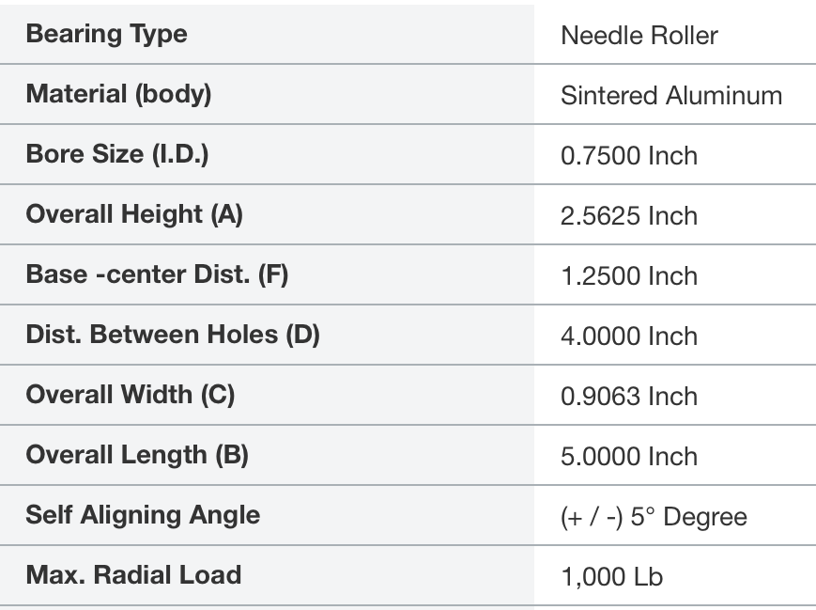
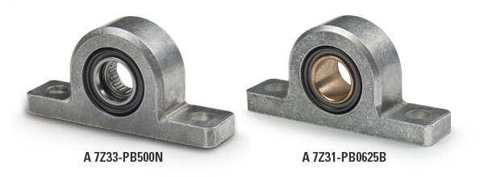
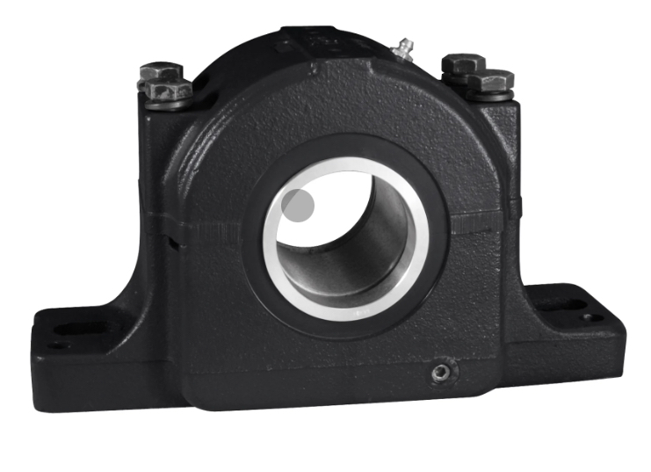


9.2 Appendix B: FMEA Table
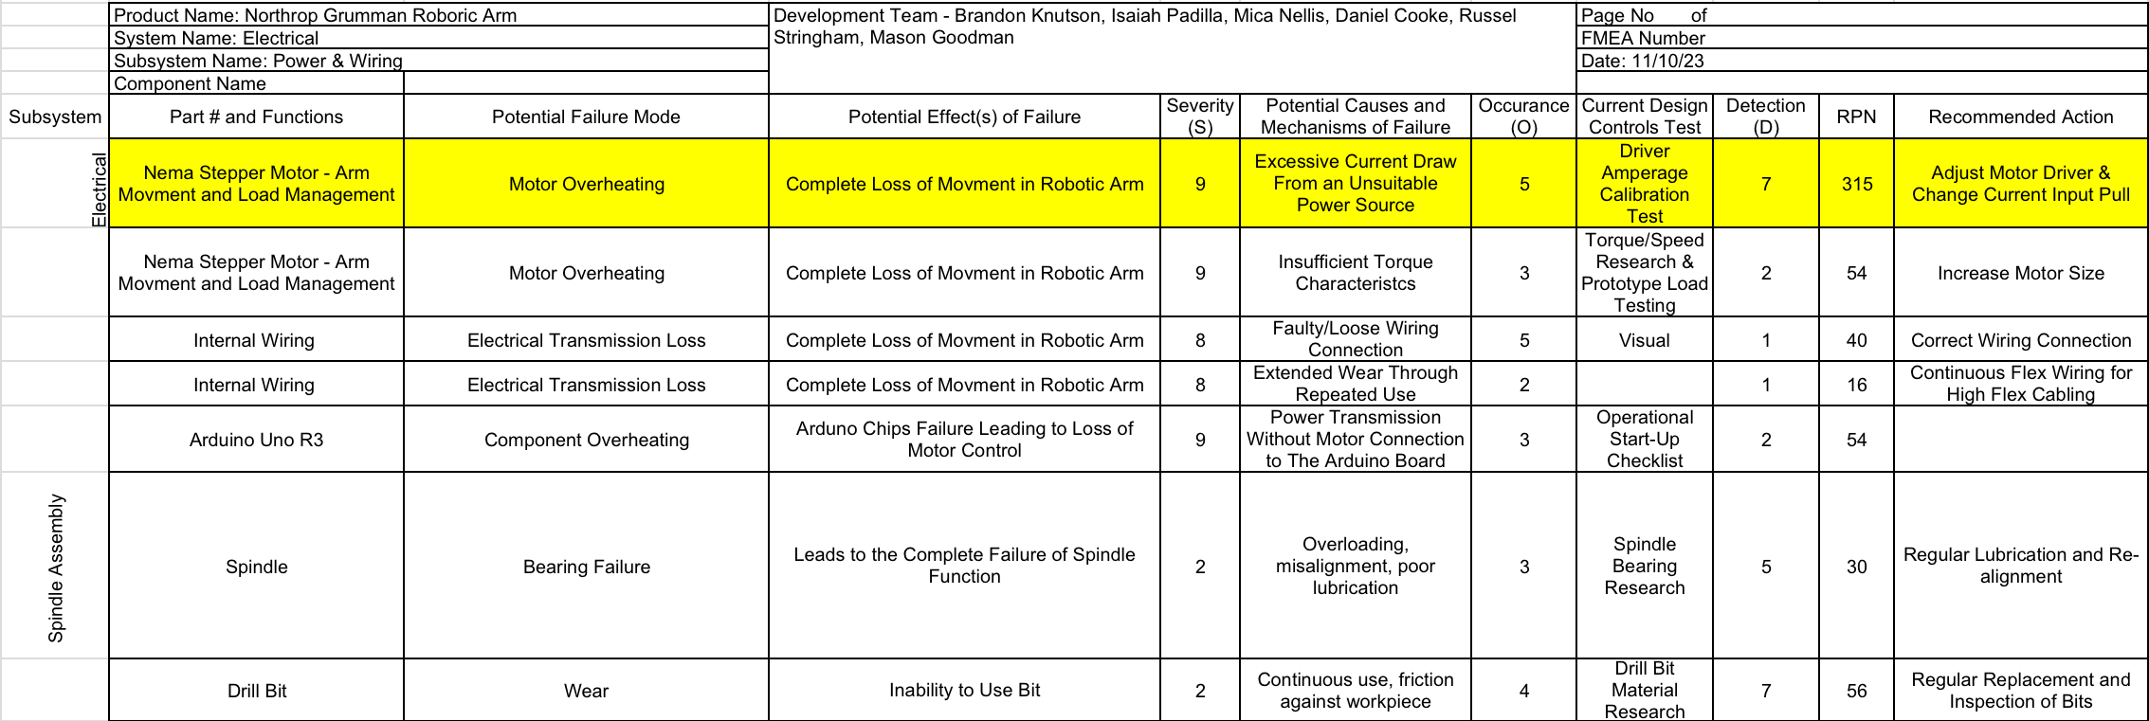
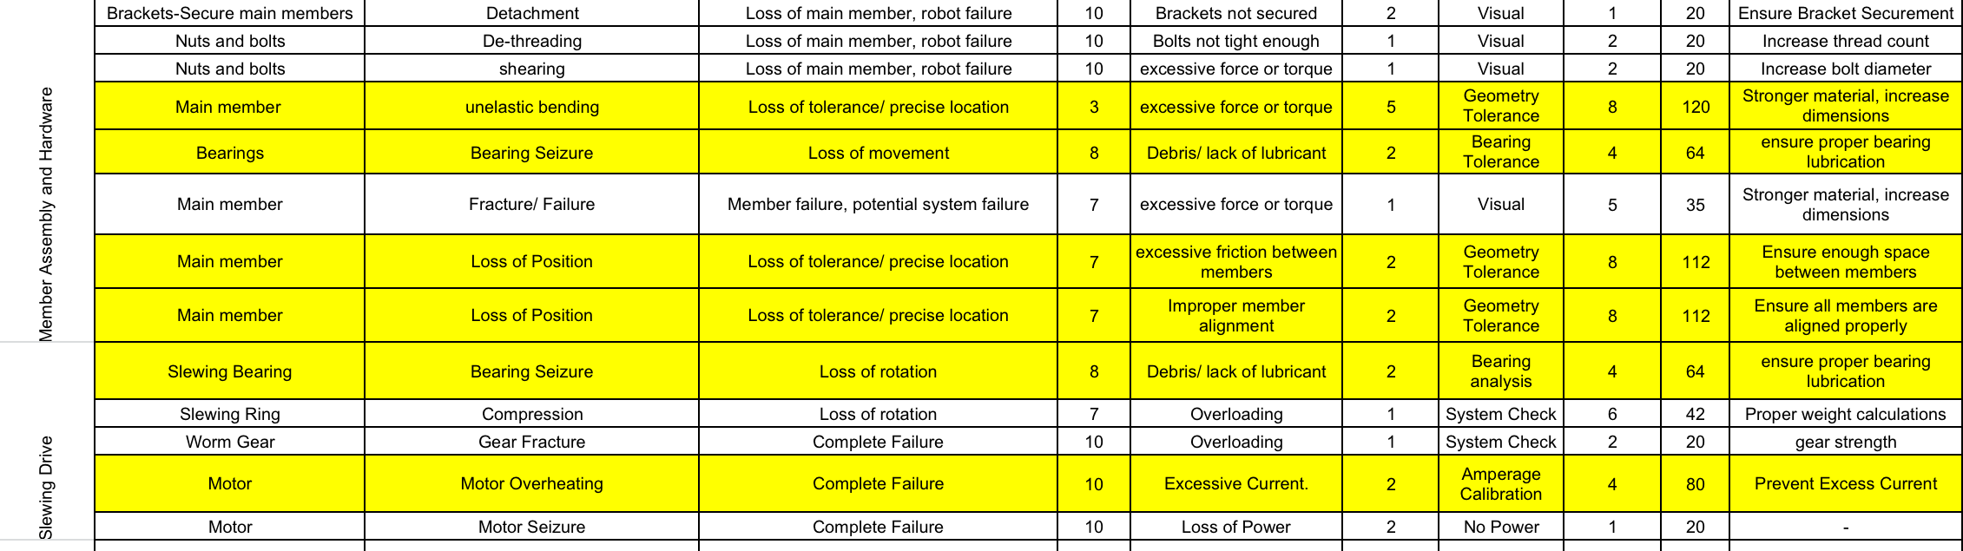

9.3 Appendix C: Final Product Bill of Materials
